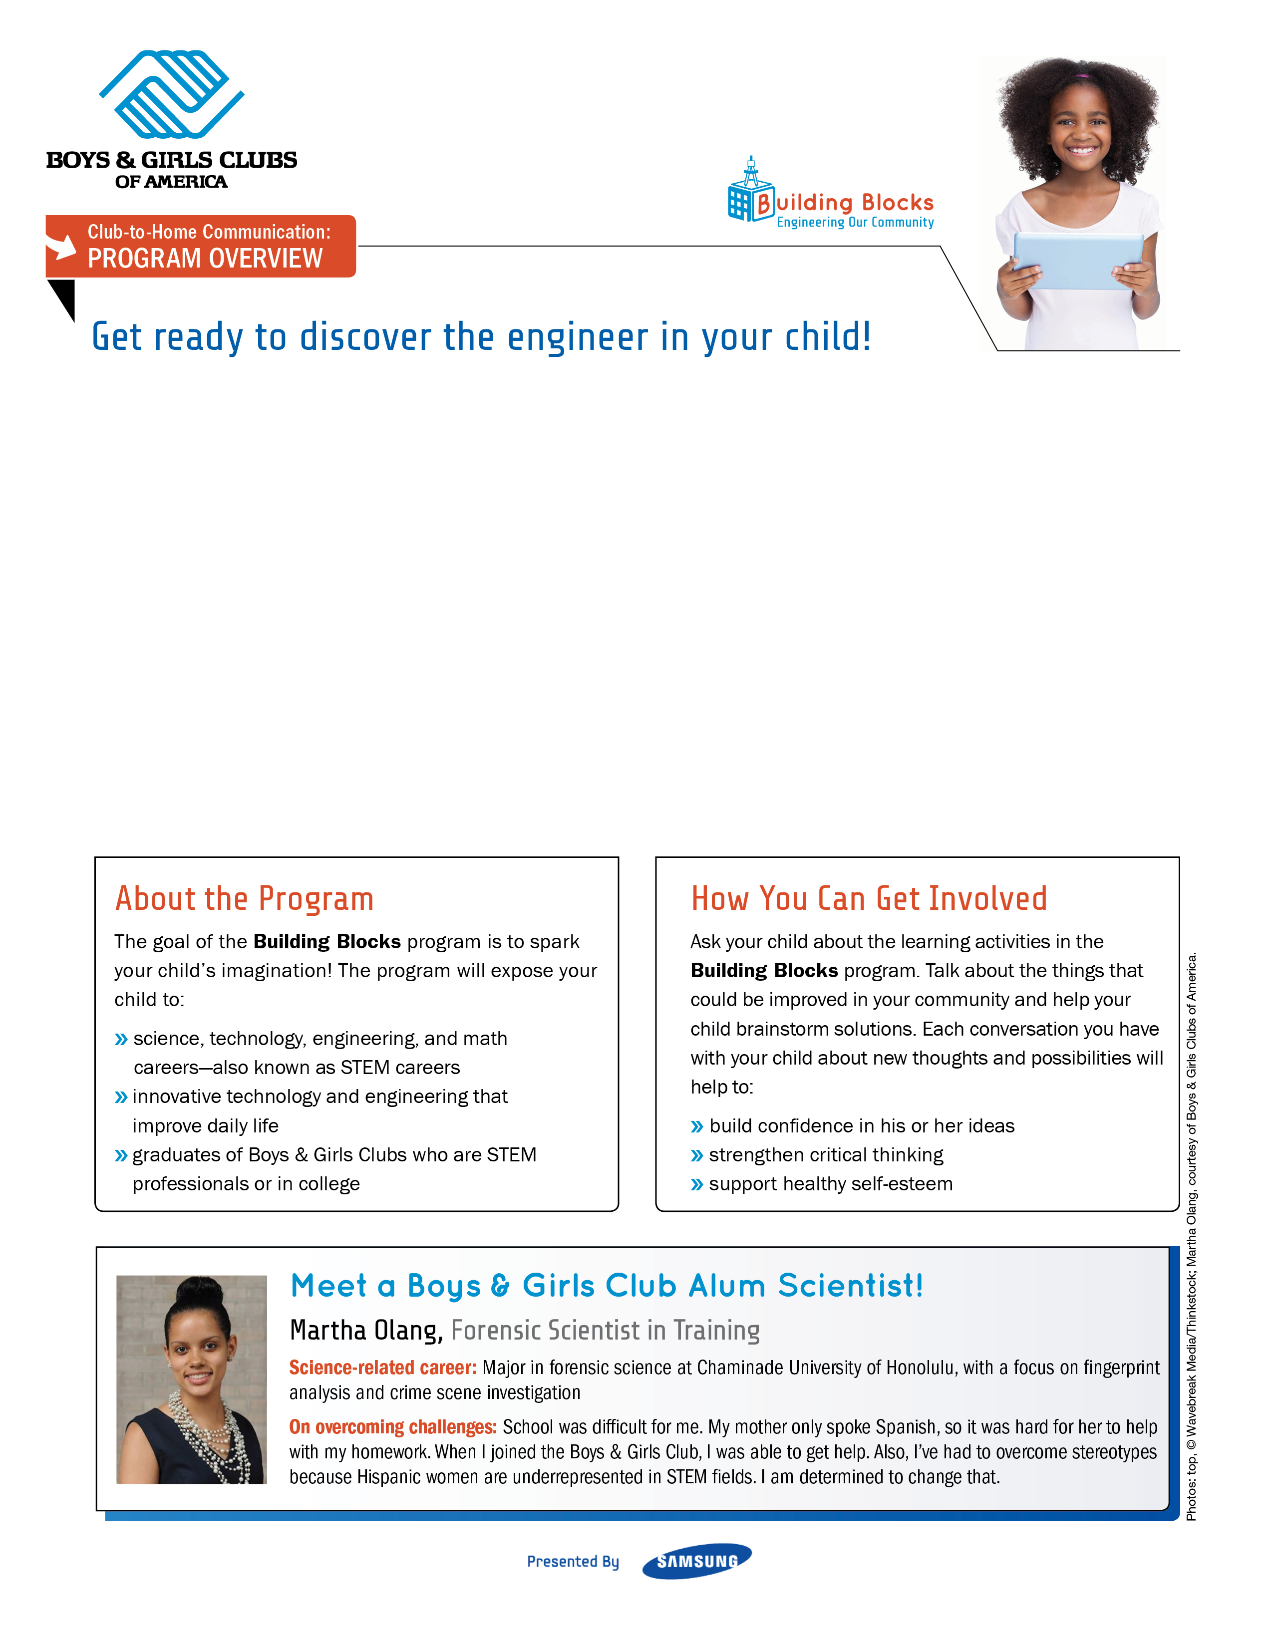
Dear Parents and Caregivers,
We’re delighted to welcome your child into an exciting new Boys & Girls Clubs program about career skills, technology, and communities. Presented by Samsung, the Building Blocks program gives your child a chance to participate in hands-on projects, showcase his or her ideas, and prepare for a brighter future.
We know activities that involve problem solving and critical thinking better prepare kids for academic and social success.
We can’t wait to work with your child to identify community challenges and help him or her brainstorm creative solutions.
Sincerely,
[Insert Club Name]



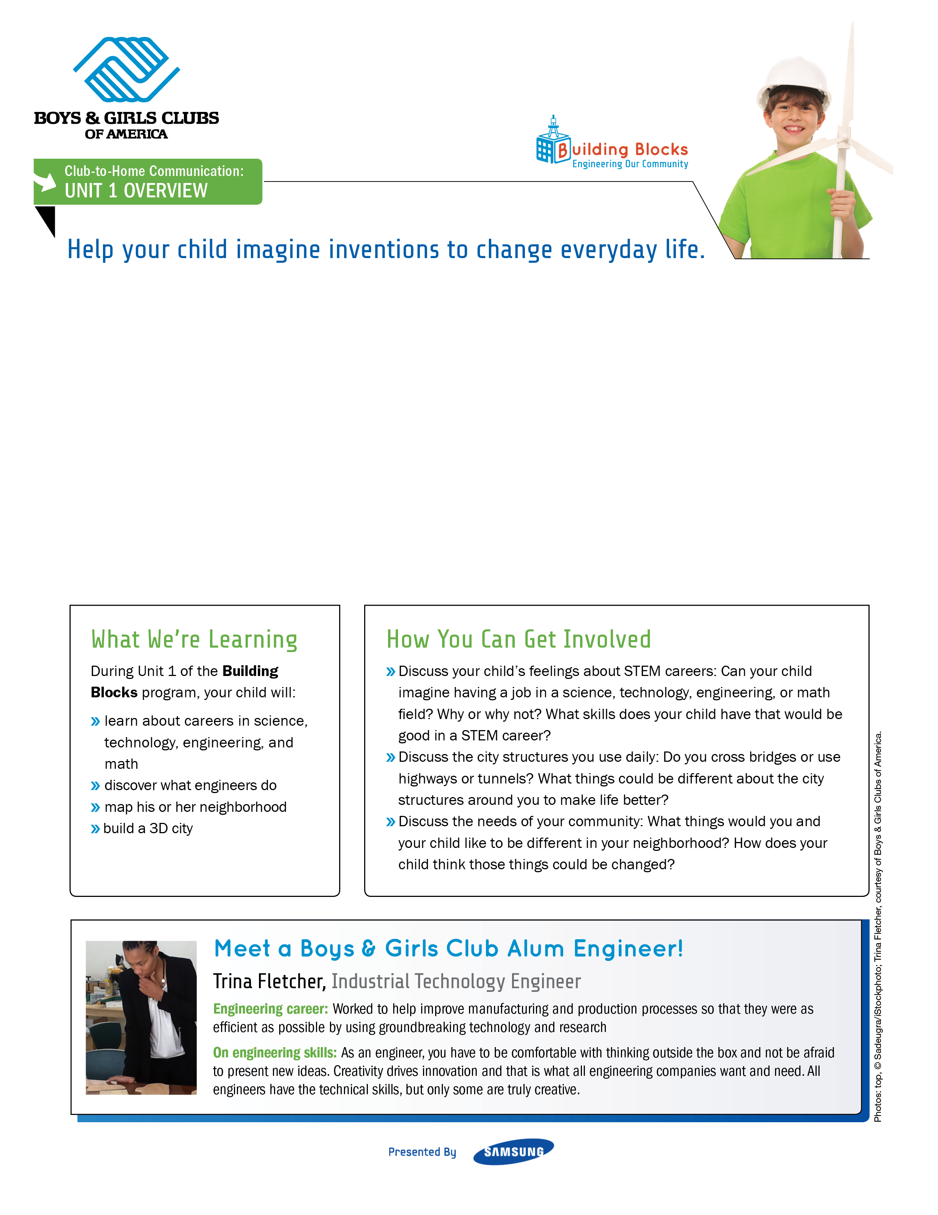
Dear Parents and Caregivers,
Did you know that there is a billboard in Peru that draws drinking water out of the air? Did you know that there is a building in Zimbabwe that is built like a termite mound to create natural cooling and heating of the air?
Did you know that your child could be the person who thinks of the next amazing innovation that improves the lives of everyone around him or her?
Your child will start this project by learning about engineering in everyday life. Read on to see how you can
get involved.
Sincerely,
[Insert Club Name]

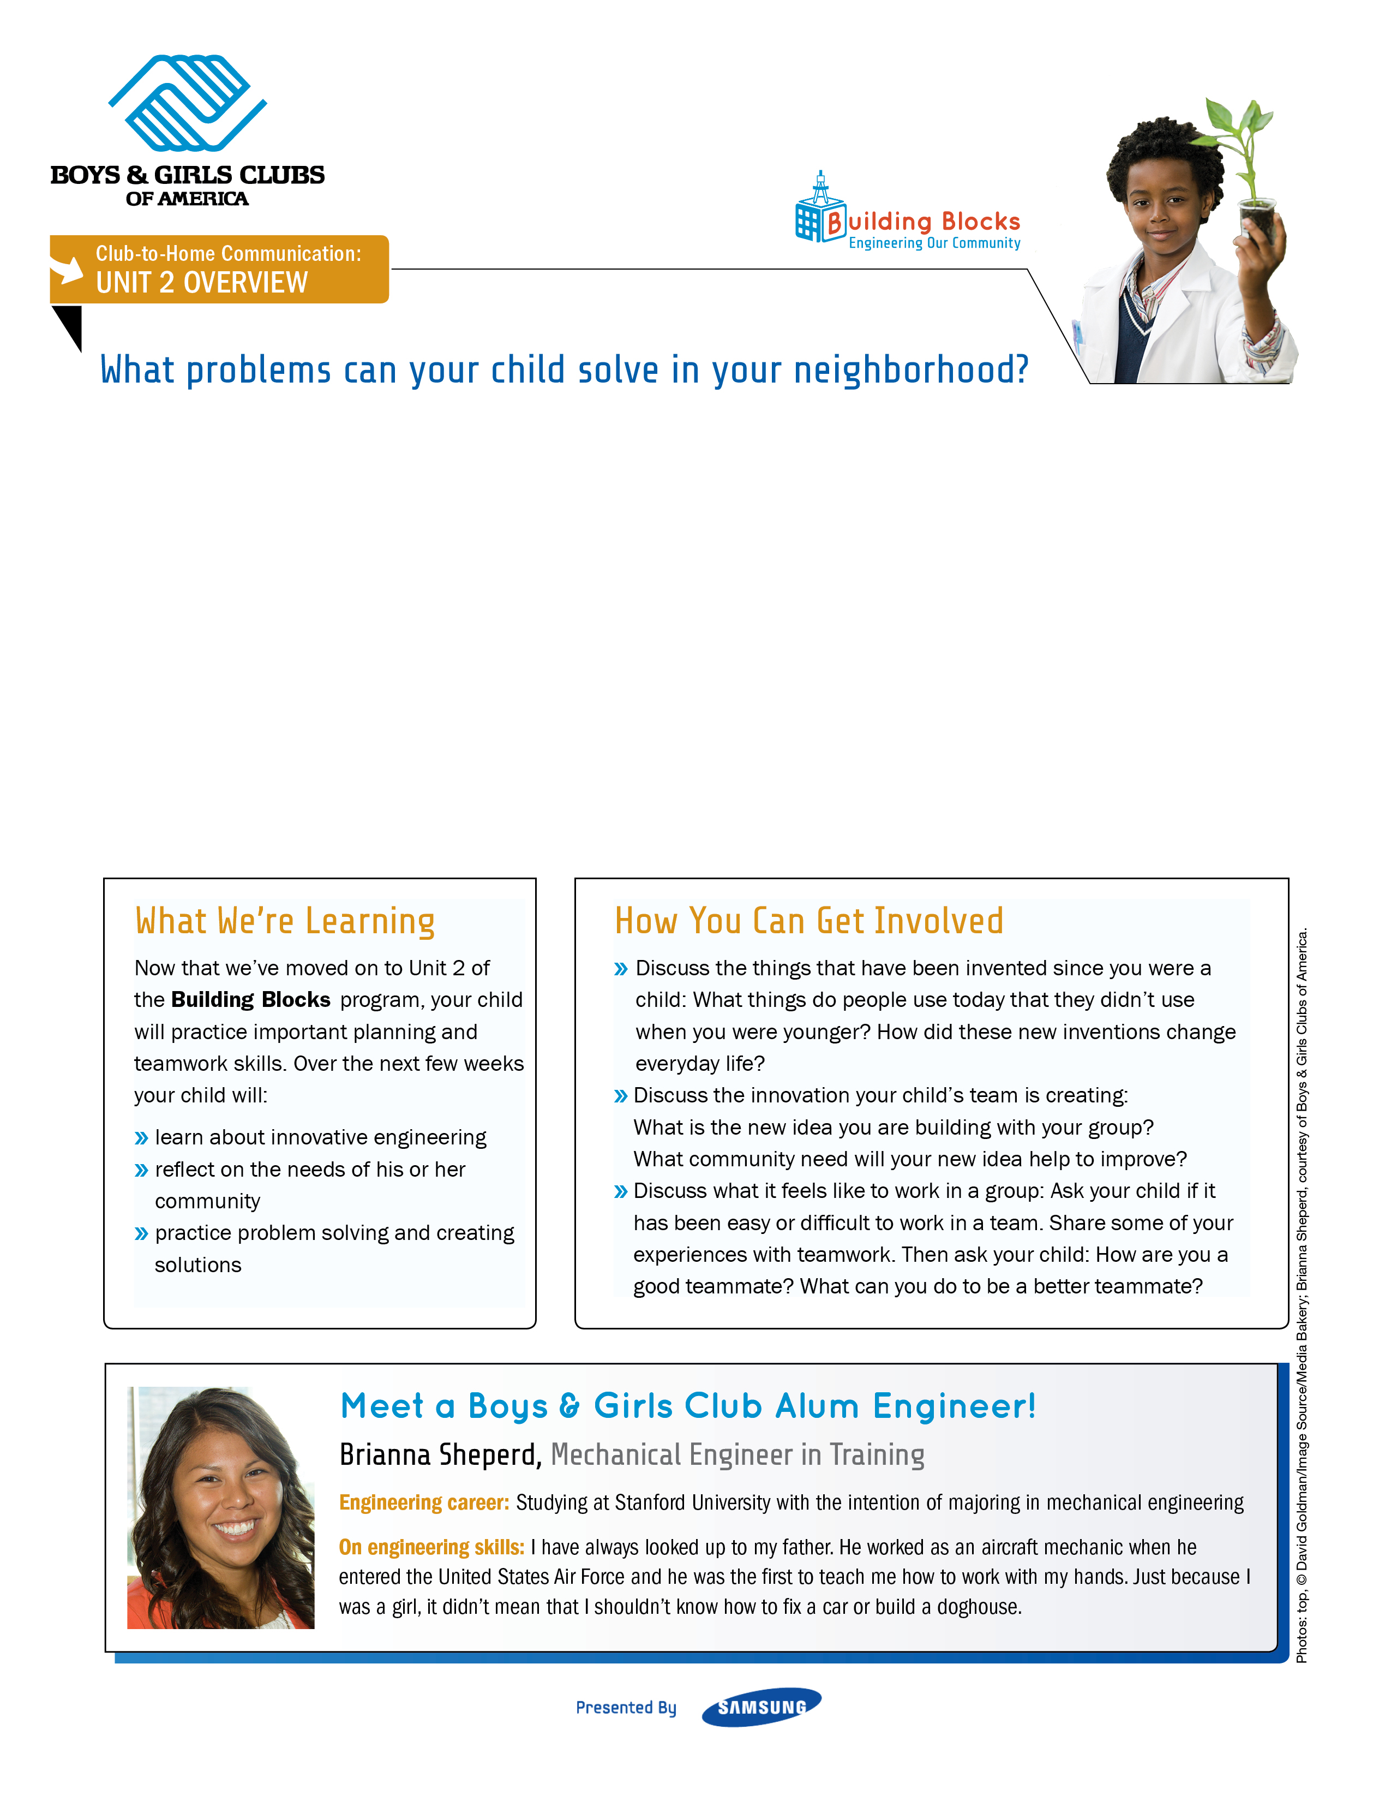
Dear Parents and Caregivers,
Organization and planning are two skills your child needs to build a successful future. It is so important for kids to be able to break up a project into doable stages and plan how much time it will take to complete. In Unit 2, your child will put problem-solving and planning skills together to create a new engineering innovation with his or her own design team!
Sincerely,
[Insert Club Name]

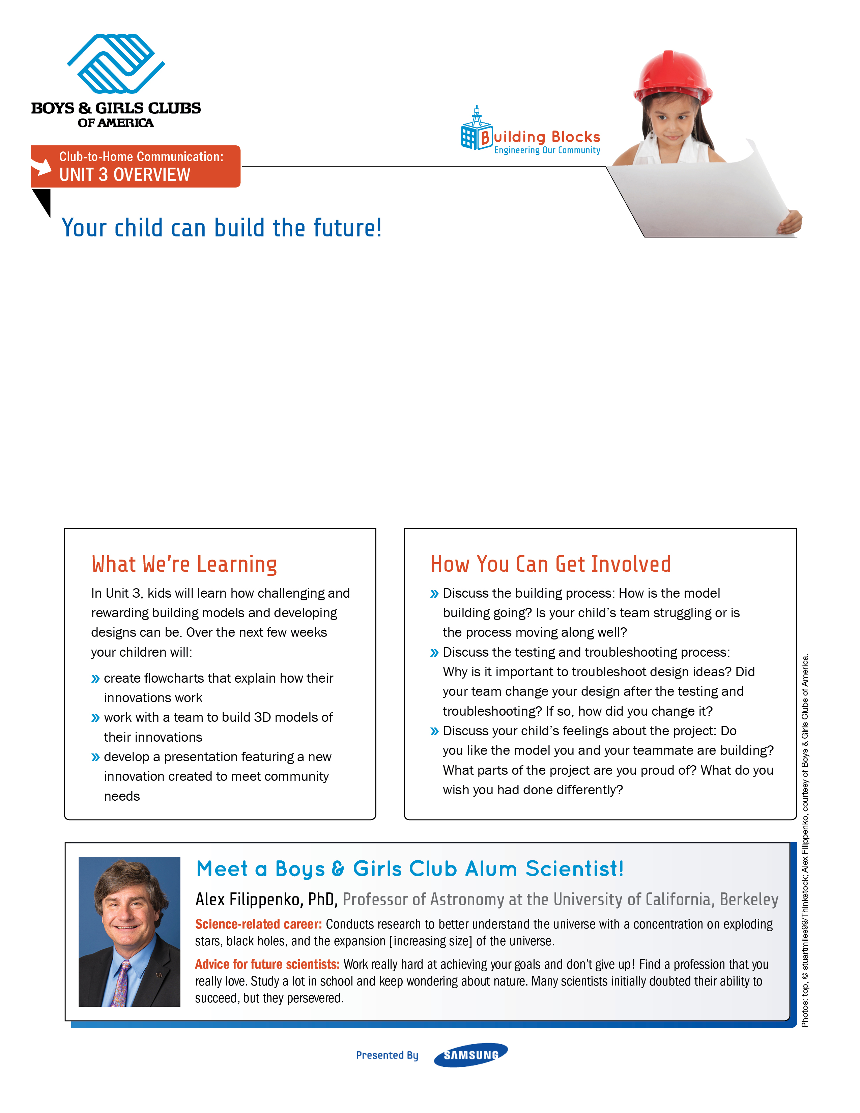
Dear Parents and Caregivers,
Every child is born with imagination, but not all of us get a chance to develop our ideas. During Unit 3 of the Building Blocks program, your child will work with his or her team to create a presentation that puts his or her ideas onstage.
Sincerely,
[Insert Club Name]

