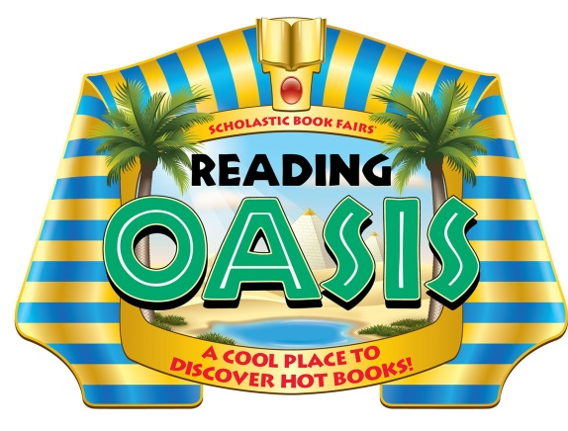Seeking Volunteers
for our Book Fair

Dear Parents and Families,

The Scholastic Book Fair® will be at our school [Insert Date Here] and special Family Events are scheduled for [Insert Date Here].

The exciting theme for our fall 2013 Book Fair is Reading Oasis: A Cool Place to Discover Hot Books! Our Book Fair will be a journey back to Ancient Egypt overflowing with hundreds of book treasures just waiting to be discovered. We hope you will share your talents and join us as we help students discover the power of reading.

If you have some time to help us plan or conduct our next Book Fair, please complete the form below and circle the areas where you would like to help out. Send the form back to [Insert Contact Info Here].

Sincerely,

[Insert Name Here]
Book Fair Chairperson

Sign me up to help at the Book Fair!

Name Telephone
E-mail

I have circled areas where I’d like to help out:
• Advertising • Decorating
• Setting up the Fair • Securing community sponsors
• Serving refreshments • Helping shoppers at the Fair
• Cashiering • Packing up the Fair
• [Insert Additional Info Here]
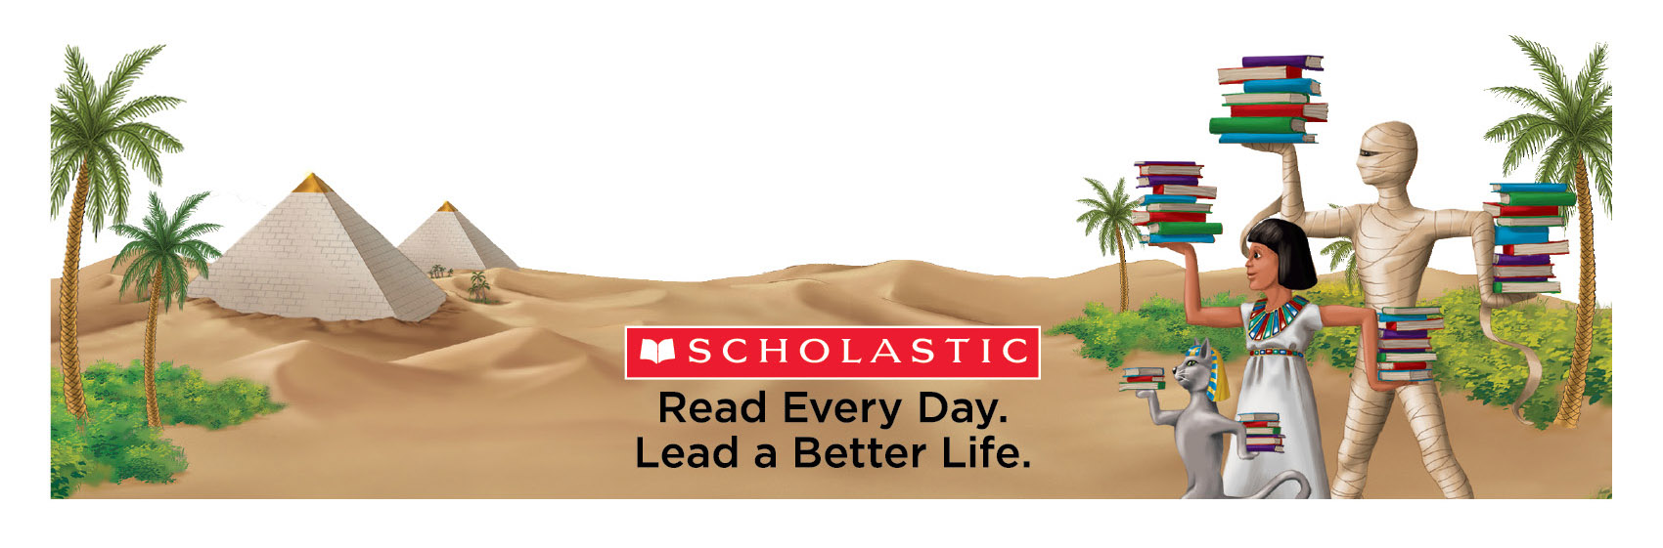
Permission to reproduce this item is granted by Scholastic Book Fairs.
© 2013 Scholastic Inc. 10921 • 131401

