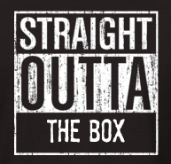

the “unboxing” game
planning sheet

topic
attributes
contributions
impact
other

- 15 minutes to plan (collect items and write script)
- 5 minutes to practice
- 10 minutes to video and edit

