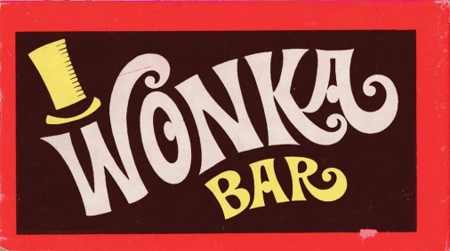

Image source: http://www.collectingcandy.com/wordpress/?p=4134

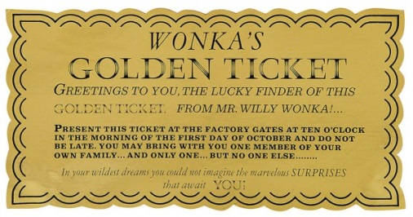
Image source: http://www.thesmartkitchenblog.com/2012/04/macadamia-choc-oconut-butter.html/0_22-original-screen-used-golden-ticket-from-willy-wonka-the-chocolate-factory1

