This problem requires you to show your work and/or explain your reasoning. You may use drawing, words, and/or numbers in your answer. Your answer should be written so that another person could read it and understand your reasoning. It is important that you show all your work.

A vert ram is a type of half-pipe that is used for extreme sports like skateboarding, snowboarding, BMX, and inline skating. A mega ramp is a very large vert ramp. In the 2011 X-Games, a mega ramp used measured 62 feet tall and 293 feet long.
- How many inches tall is the ramp?
- How many inches long is the ramp?
- How many inches tall are you?
- If you were lined up over and over again (head to toe), how many of you would be needed to make a ramp that tall and that long?

Show all your work in the and/or explain your reasoning for each part in the space provided in the answer document.

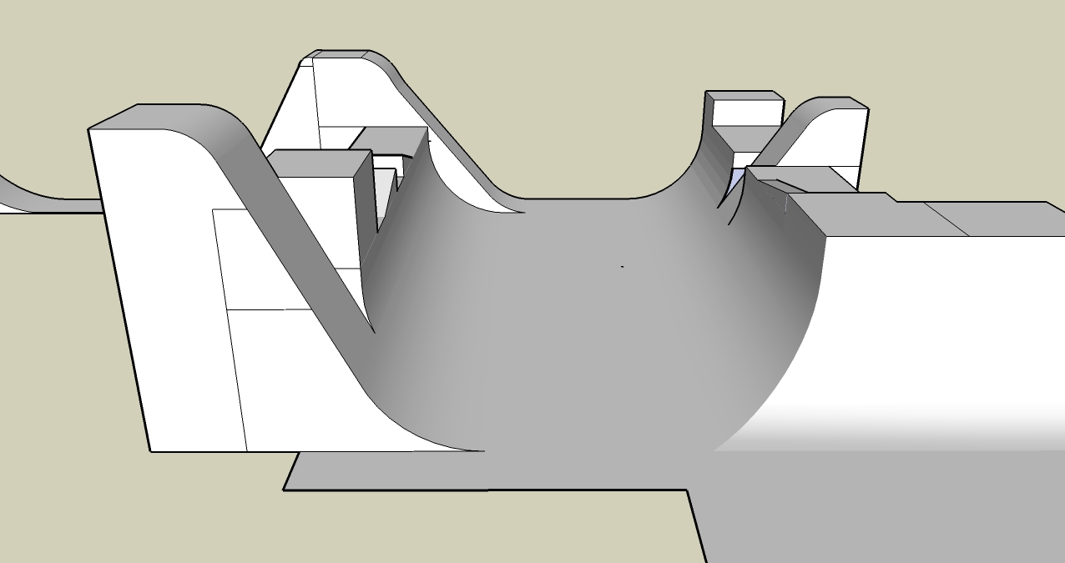

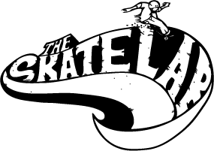
This problem requires you to show your work and/or explain your reasoning. You may use drawing, words, and/or numbers in your answer. Your answer should be written so that another person could read it and understand your reasoning. It is important that you show all your work.

Skatelab is a southern California indoor skate park. For $10, you can skate for 3-hour session. The owner tells you that it costs $225 per hour for his expenses (such as rent, insurance, and, employee wages).
- How many customers are needed each session to make a profit?
- If the fee is raised to $15, how many customers are needed to make a profit?
- How much more profit would there be if 100 skaters paid $15 rather than $10?

Show all your work in the and/or explain your reasoning for each part in the space provided in the answer document.

- If three of the four wheels on your skateboard are in need of repair, what fraction of the wheels need repair? Show your answer as a decimal. |  | 7. A kid online says he has the largest Tech Deck collection with 456 decks. If they were sold in packs of 3, how many packages did he buy?
- A Tech Deck skateboard toy is nine and six-tenths decimeters long. How long is that written in standard form? |  | 8. Portland, Oregon is the “skateboarding capitol of the world.” It has 19 skate parks for its six hundred thousand residents. How many residents is that in standard form?
- Tech Decks are 30mm wide. How many decks could fit side by side on a meter stick? |  | 9. Skateboard helmets decrease injuries by 85%. They can cost up to $50. If a rider purchased a helmet and had $15 left what was the cost of the helmet?  $50 – h = $15
- Skateboard are made of 7 layers of plywood. How many layers are used in 549 skateboards? |  | 10. Of the skateboarding deaths in 2011, 40 were outside of a skatepark and one was within a skatepark. How many total deaths, in or out of a park, were reported?
- The world’s largest skateboard is twelve and a half times larger than a regular skateboard. What is that written in decimal form? |  | 11. Skateboarding is believed to have been created in the late 1940s. About how many years has skateboarding existed?
- A number of skateboarders died by “bombing”. Twice as many died doing street skateboarding. If The number of skateboarders that died doing street is 26, how many died while bombing?  2x = 26 |  | 12. A professional skateboard can cost up to $400. If you purchased an average skateboard for $54.98, skateboarding shoes for $63.29, a helmet for $24.99, and three decals that cost $3.50 each, how much would your purchase total?

