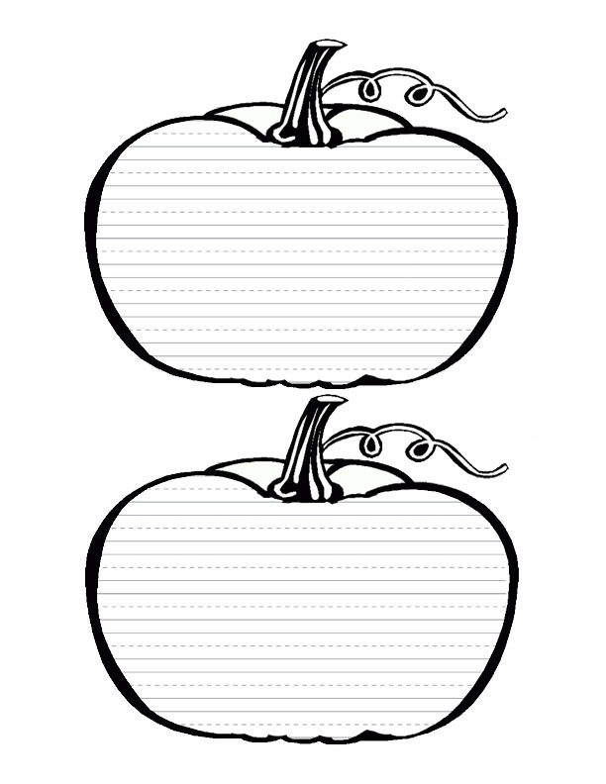

Is there something on the inside of the pumpkin that lines up with the creases on the outside?

There are creases that run side by side (stem to bottom) on the outside of a pumpkin. Are there more creases on bigger pumpkins than on a smaller one?



Where on a pumpkin the creases the deepest? The shallowest?

Where on a pumpkin are the creases the closest together? The farthest apart?



Do pumpkins with more creases have more seeds?

Are the creases closer together on bigger pumpkins than on smaller ones?



By looking at a pumpkin can you tell which side was on the ground?

From looking only at the stem, can you determine which side of the pumpkin was on the ground?



Are the seeds scattered around inside a pumpkin or are they arranged in certain groups and patterns?

Are pumpkins mostly full or mostly empty?



If we call the stem end of the pumpkin "up" do the pointed ends of the seeds point up, down, sideways or in different directions.

If the seed are in groups and patterns, are the groups and patterns the same for different pumpkins?



Think of a way of finding the number of seeds in a pumpkin without actually counting each seed.

What is the relationship between pumpkin size and seed size? Do bigger pumpkins have bigger seeds?



In one pumpkin are the seeds all the same size? If not, where are the seeds the largest? The smallest?

Do bigger pumpkins have more seeds than smaller pumpkins?



Hit pumpkins of different sizes to see where you get the lowest and highest sounds.

Hit pumpkins of different sizes to see where you get the lowest and highest sounds.



If pumpkins do float, determine whether bigger pumpkins float higher out of the water than smaller pumpkins.

Do pumpkins float in water? Do pumpkins float right side up, upside-down, or on their sides. If they float on their sides, determine where the ground side floats (up, down, sideways or any direction)



Try to figure out what the stringy stuff on the inside of the pumpkin does. Is it attached to the shell? The seeds?

A pumpkin was once the bottom part of a beautiful, yellow flower. Find the place on the pumpkin where the blossom part of the flower grew.



How big around do you think your pumpkin is? How big around is it actually? Did you guess to long, too short, or just right?

How many cubes tall do you think your pumpkin is? How tall is it actually?



My Actual Pumpkin Seed Count

My Pumpkin Seed Estimate #1 and #2