Directions: Read the passage and answer the questions.
Doing More Research
There are plenty of ways to learn even more about knights and castles. The fun of research is seeing how many different sources you can explore.

Selection from Knights and Castles p.108-109
BOOKS
Most libraries and bookstores have lots of books about knights, castles, and life in the Middle Ages. Here are some things to remember when you’re using a book for research:
1. You don’t have to read the whole book.
Check the table of contents and the index to find the topics you’re interested in.
2. Write down the name of the book.
When you take notes, make sure you write down the name of the book in your notebook so you can find it again.
3. Never copy exactly from a book.
When you learn something new from a book, put it in your own words.
4. Make sure the book is nonfiction.
There are many books that tell make-believe stories about knights and castles. Make believe stories are called fiction. They’re fun to read, but they’re not good for research.

Research books have real facts and tell true stories. They are called nonfiction. A librarian or teacher can help you make sure the books you use for research are nonfiction.

1. What do you need to write when you take notes?
a. Copy exactly from the book.
b. The word nonfiction
c. The name of the book
d. Copy the Table of Contents
2. Which is NOT a way to tell if a book is nonfiction?
a. Read a make-believe story
b. Check for facts
c. Ask a teacher or librarian
d. Use the research book section in the library

3. What does the word sources mean in the second paragraph?
a. Books
b. Dictionaries
c. Places to find information
d. People

4. What would be an example of a nonfiction book?
a. A Kid in King Arthur’s Court
b. Sleeping Beauty’s Castle
c. The Magic Tree House in Outer Space
d. Animals and Their Habitats

Directions: Read the passage and answer the questions.
Selection from Knights and Castles p.95-96
Many knights fought their hardest battles close to home. They had to defend their lord’s castle against enemy attack.
Sieges
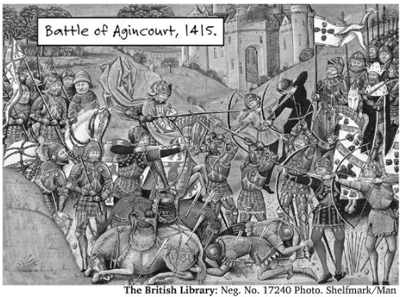
Sometimes an enemy would try to take over a castle by surprise. A castle in England was once invaded by soldiers hiding in a wagon full of hay!
A more common way to try to take over a castle was by siege (SEEJ).
During a siege, the enemy army surrounded the castle. They kept people in the castle from coming out. They kept food and supplies from going in.
The attacking army tried very hard to get inside the castle. They often built special weapons to help them. These weapons were called siege engines.
Some siege engines were huge. The biggest was called a belfry (BEL-free). A belfry was a rolling tower. It was as tall as the castle walls. It could hold hundreds of soldiers.
During a siege, the enemy army would roll the belfry up to the castle walls. Then they would open the top. The soldiers inside would climb out and try to go over the battlements.
A belfry was also called a “cat” or a “bear”.
For nearly 200 years, Christian knights called Crusaders fought to claim land in the Middle East.
5. What is the main idea of this passage?
a. Belfries were large, rolling towers for soldiers.
b. Crusaders fought for over 200 years in the Middle East.
c. Attacking armies tried very hard to get inside the castle.
d. Many knights fought hard battles defending their lord’s castle against enemies.
6. Why did the author include a caption on the image?
a. The author wanted to add interest with a caption.
b. The captions tells what Annie would have said.
c. The caption describes the picture.
d. The author wanted to use a different kind of writing.

7. What is the purpose of the words (SEEJ) and (BEL-free)?
a. They are a different way to spell siege and belfry.
b. They are synonyms for the words siege and belfry.
c. They are the words siege and belfry in a different language.
d. They are the way you say the words siege and belfry.

8. Who were the Crusaders?
a. The Crusaders were people who used belfries.
b. The Crusaders were Christian knights.
c. The Crusaders were the enemy army.
d. The Crusaders were knights defending their lord’s castle.

9. Which topic would best fit in this section about sieges?
a. Battering rams – items used to bash in castle doors
b. Joust – a game played at castle tournaments
c. Code of Chivalry – the behavior rules for knights and gentlemen
d. Guilds – a group of master craftsmen who made items

10. Which of the following is an opinion about castles?
a. Many castles were dark because there was no electricity.
b. Moats were the best way to keep people out of the castle.
c. Soldiers once invaded a castle by hiding in a wagon full of hay.
d. Fairy tales often have make-believe castles

11. Write a short summary of the passage about sieges. Be sure to include the main idea, but do not include unimportant details. Write your answer in COMPLETE SENTENCES!!!
_______________________________________________________________________

_______________________________________________________________________

_______________________________________________________________________

_______________________________________________________________________

_______________________________________________________________________

_______________________________________________________________________

_______________________________________________________________________

_______________________________________________________________________

