Name: _______________________________________ Date: _______________
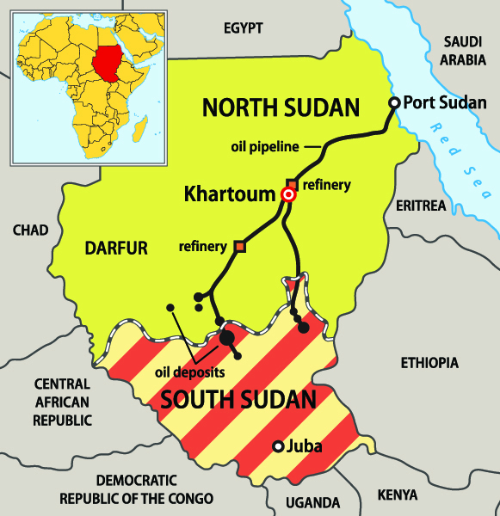
The Lost Boys
Directions: Answer the questions below using the map to the right and reading the article “Lost Boy Found” to answer the questions below.

- Joseph’s 1,000 mile journey began in ____________ and ended in _______________________________.

- According to the map, in which direction did Joseph travel? ____________________________________

- Why does Joseph celebrate his birthday on January 1? __________________________________________________________________________________________________________________________________________________________________
Photo Credit: Peteri /IStockphoto

- Explain what happened to Joseph’s family. ______________________________________________ ___________________________________________________________________________________________________________________________________________________________________________________________________________________________________________________

- In what ways is Joseph similar and different to other college students? Use details from the article to fill in the cart below.
Similar | Different

- Joseph says it is his “sense of duty to bear witness to what had happened to him and other Lost Boys.” Explain what he means.
_____________________________________________________________________________________________________________________________________________________________________________________________________________________________________________________________________________________________________________________________________________________________________________________________________________________

