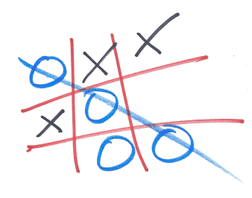

Do one of the activities below in your reading binder and mark it off with an **X**. The next time you do an activity, mark it with a O. Switch back and forth between **X** and **O** until you have a tic tac toe!

|  |  |  |
| --- | --- | --- |
| Why did you choose this book to read?  C:\Users\Genia\AppData\Local\Microsoft\Windows\Temporary Internet Files\Content.IE5\7UHZJS1J\MC900382576[1].jpg | C:\Documents and Settings\econnell\Local Settings\Temporary Internet Files\Content.IE5\Z4T6WYDC\MC900234134[1].wmfWrite a three sentence summary of what you read today. Write the details in order. | C:\Users\Genia\AppData\Local\Microsoft\Windows\Temporary Internet Files\Content.IE5\XAYS3ICV\MC900384172[2].wmfIf you could ask your main character one question, what would it be? |
| What character in your story would you like to invite over to your house? Explain why.  C:\Users\Genia\AppData\Local\Microsoft\Windows\Temporary Internet Files\Content.IE5\ADN2V93X\MC900438247[1].wmf | If you were the author, what’s one thing you would change about the book and why?  C:\Users\Genia\AppData\Local\Microsoft\Windows\Temporary Internet Files\Content.IE5\ADN2V93X\MC900363714[1].wmf | If you wrote a sequel to this book, what title would you give it and why?  http://alanrinzler.com/blog/wp-content/uploads/2008/07/t2.jpg |
| C:\Users\Genia\AppData\Local\Microsoft\Windows\Temporary Internet Files\Content.IE5\Z3BVRTXR\MC900286890[1].wmfDescribe the setting in your book including time and place. | C:\Users\Genia\AppData\Local\Microsoft\Windows\Temporary Internet Files\Content.IE5\XAYS3ICV\MC900290334[1].wmfYou are going to give one character in your book an award for one of their character traits. What would the award be and why? | C:\Users\Genia\AppData\Local\Microsoft\Windows\Temporary Internet Files\Content.IE5\7UHZJS1J\MC900446310[1].wmfWhat lesson do you think the author wants you to learn from reading this story? |