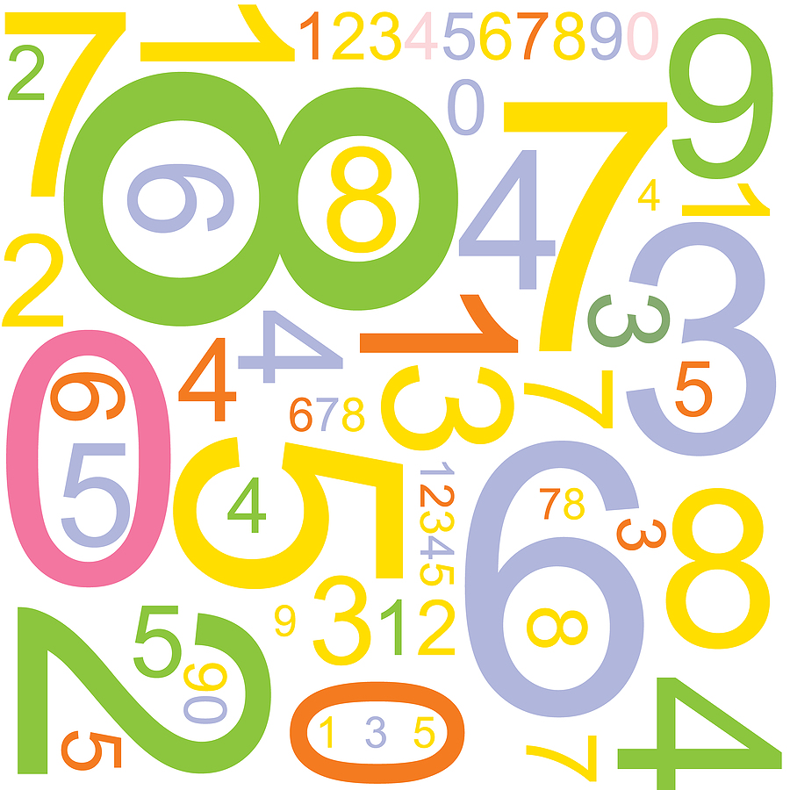

|  |  |  |  |  |
| --- | --- | --- | --- | --- |
| 2 | 2 | 3 | 3 | 4 |
| 4 | 5 | 5 | 6 | 6 |
| 7 | 7 | 8 | 8 | 9 |
| 9 | 10 | 10 | 11 | 11 |
| 12 | 12 | Mixed | Mixed | Final |

|  |  |  |  |  |
| --- | --- | --- | --- | --- |
| 2 | 2 | 3 | 3 | 4 |
| 4 | 5 | 5 | 6 | 6 |
| 7 | 7 | 8 | 8 | 9 |
| 9 | 10 | 10 | 11 | 11 |
| 12 | 12 | Mixed | Mixed | Final |



|  |  |  |  |  |
| --- | --- | --- | --- | --- |
| 2 | 2 | 3 | 3 | 4 |
| 4 | 5 | 5 | 6 | 6 |
| 7 | 7 | 8 | 8 | 9 |
| 9 | 10 | 10 | 11 | 11 |
| 12 | 12 | Mixed | Mixed | Final |

|  |  |  |  |  |
| --- | --- | --- | --- | --- |
| 2 | 2 | 3 | 3 | 4 |
| 4 | 5 | 5 | 6 | 6 |
| 7 | 7 | 8 | 8 | 9 |
| 9 | 10 | 10 | 11 | 11 |
| 12 | 12 | Mixed | Mixed | Final |