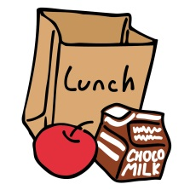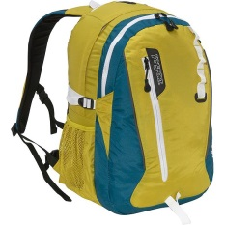

Morning Routine

1. Empty your backpack.
2. Put your homework folder in your mailbox with your homework on top.
3. Put your lunch in the basket
4. Sign up for lunch count
5. Hang your empty backpack on the back hook and your coat on the front hook.
6. Sit down and begin your morning work.