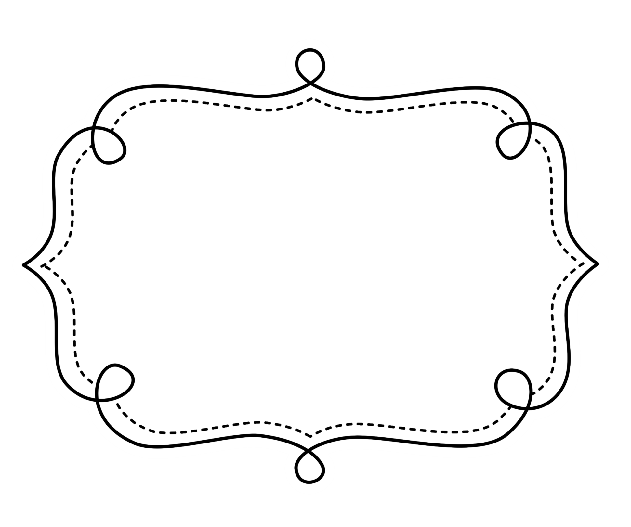
Common Core
Lesson Tracker
English Language Arts
Grade 5
Common Core Lesson Tracker for Grade 5 English Language Arts
Reading: Literature
Key Ideas and Details
CCSS | Introduced | Practiced | Practiced | Assessed | Outcome
CCSS.ELA-Literacy.RL.5.1 Quote accurately from a text when explaining what the text says explicitly and when drawing inferences from the text.
CCSS.ELA-Literacy.RL.5.2 Determine a theme of a story, drama, or poem from details in the text, including how characters in a story or drama respond to challenges or how the speaker in a poem reflects upon a topic; summarize the text.
CCSS.ELA-Literacy.RL.5.3 Compare and contrast two or more characters, settings, or events in a story or drama, drawing on specific details in the text (e.g., how characters interact).
Craft and Structure
CCSS | Introduced | Practiced | Practiced | Assessed | Outcome
CCSS.ELA-Literacy.RL.5.4 Determine the meaning of words and phrases as they are used in a text, including figurative language such as metaphors and similes.
CCSS.ELA-Literacy.RL.5.5 Explain how a series of chapters, scenes, or stanzas fits together to provide the overall structure of a particular story, drama, or poem.
CCSS.ELA-Literacy.RL.5.6 Describe how a narrator’s or speaker’s point of view influences how events are described.
Integration of Knowledge and Ideas Reading Literature
CCSS | Introduced | Practiced | Practiced | Assessed | Outcome
CCSS.ELA-Literacy.RL.5.7 Analyze how visual and multimedia elements contribute to the meaning, tone, or beauty of a text (e.g., graphic novel, multimedia presentation of fiction, folktale, myth, poem).
(RL.5.8 not applicable to literature)
CCSS.ELA-Literacy.RL.5.9 Compare and contrast stories in the same genre (e.g., mysteries and adventure stories) on their approaches to similar themes and topics.
Range of Reading and Level of Text Complexity
CCSS | Checkpoint | Checkpoint | Checkpoint | Checkpoint | Outcome
CCSS.ELA-Literacy.RL.5.10 By the end of the year, read and comprehend literature, including stories, dramas, and poetry, at the high end of the grades 4–5 text complexity band independently and proficiently.

Common Core Lesson Tracker for Grade 5 English Language Arts
Reading: Informational Text
Key Ideas and Details
CCSS | Introduced | Practiced | Practiced | Assessed | Outcome
CCSS.ELA-Literacy.RI.5.1 Quote accurately from a text when explaining what the text says explicitly and when drawing inferences from the text.
CCSS.ELA-Literacy.RI.5.2 Determine two or more main ideas of a text and explain how they are supported by key details; summarize the text.
CCSS.ELA-Literacy.RI.5.3 Explain the relationships or interactions between two or more individuals, events, ideas, or concepts in a historical, scientific, or technical text based on specific information in the text.
Craft and Structure
CCSS | Introduced | Practiced | Practiced | Assessed | Outcome
CCSS.ELA-Literacy.RI.5.4 Determine the meaning of general academic and domain-specific words and phrases in a text relevant to a grade 5 topic or subject area.
CCSS.ELA-Literacy.RI.5.5 Compare and contrast the overall structure (e.g., chronology, comparison, cause/effect, problem/solution) of events, ideas, concepts, or information in two or more texts.
CCSS.ELA-Literacy.RI.5.6 Analyze multiple accounts of the same event or topic, noting important similarities and differences in the point of view they represent.

Integration of Knowledge and Ideas Informational Text
CCSS | Introduced | Practiced | Practiced | Assessed | Outcome
CCSS.ELA-Literacy.RI.5.7 Draw on information from multiple print or digital sources, demonstrating the ability to locate an answer to a question quickly or to solve a problem efficiently.
CCSS.ELA-Literacy.RI.5.8 Explain how an author uses reasons and evidence to support particular points in a text, identifying which reasons and evidence support which point(s).
CCSS.ELA-Literacy.RI.5.9 Integrate information from several texts on the same topic in order to write or speak about the subject knowledgeably.
Range of Reading and Level of Text Complexity
CCSS | Checkpoint | Checkpoint | Checkpoint | Checkpoint | Outcome
CCSS.ELA-Literacy.RI.5.10 By the end of the year, read and comprehend informational texts, including history/social studies, science, and technical texts, at the high end of the grades 4–5 text complexity band independently and proficiently.

Grade 5 English Language Arts
Foundational Skills
Phonics and Word Recognition
CCSS | Introduced |  | Practiced |  | Practiced |  | Assessed |  | Outcome
CCSS.ELA-Literacy.RF.5.3 Know and apply grade-level phonics and word analysis skills in decoding words.
CCSS.ELA-Literacy.RF.5.3a Use combined knowledge of all letter-sound correspondences, syllabication patterns, and morphology (e.g., roots and affixes) to read accurately unfamiliar multisyllabic words in context and out of context.
Fluency
CCSS.ELA-Literacy.RF.5.4 Read with sufficient accuracy and fluency to support comprehension.
CCSS.ELA-Literacy.RF.5.4a Read grade-level text with purpose and understanding.
CCSS.ELA-Literacy.RF.5.4b Read grade-level prose and poetry orally with accuracy, appropriate rate, and expression on successive readings.
CCSS.ELA-Literacy.RF.5.4c Use context to confirm or self-correct word recognition and understanding, rereading as necessary.

Common Core Lesson Tracker for Grade 5 English Language Arts
WRITING
Text Types and Purposes
CCSS | Introduced | Practiced | Practiced | Assessed | Outcome
CCSS.ELA-Literacy.W.5.1 Write opinion pieces on topics or texts, supporting a point of view with reasons and information.
CCSS.ELA-Literacy.W.5.1a Introduce a topic or text clearly, state an opinion, and create an organizational structure in which ideas are logically grouped to support the writer’s purpose.
CCSS.ELA-Literacy.W.5.1b Provide logically ordered reasons that are supported by facts and details.
CCSS.ELA-Literacy.W.5.1c Link opinion and reasons using words, phrases, and clauses (e.g., consequently, specifically).
CCSS.ELA-Literacy.W.5.1d Provide a concluding statement or section related to the opinion presented.
CCSS.ELA-Literacy.W.5.2 Write informative/explanatory texts to examine a topic and convey ideas and information clearly..
CCSS.ELA-Literacy.W.5.2a Introduce a topic clearly, provide a general observation and focus, and group related information logically; include formatting (e.g., headings), illustrations, and multimedia when useful to aiding comprehension.
CCSS.ELA-Literacy.W.5.2b Develop the topic with facts, definitions, concrete details, quotations, or other information and examples related to the topic.
CCSS.ELA-Literacy.W.5.2c Link ideas within and across categories of information using words, phrases, and clauses (e.g., in contrast, especially).
Writing
Text Types and Purposes (cont.)
CCSS | Introduced | Practiced | Practiced | Assessed | Outcome
CCSS.ELA-Literacy.W.5.2d Use precise language and domain-specific vocabulary to inform about or explain the topic.
CCSS.ELA-Literacy.W.5.2e Provide a concluding statement or section related to the information or explanation presented.
CCSS.ELA-Literacy.W.5.3 Write narratives to develop real or imagined experiences or events using effective technique, descriptive details, and clear event sequences.
CCSS.ELA-Literacy.W.5.3a Orient the reader by establishing a situation and introducing a narrator and/or characters; organize an event sequence that unfolds naturally.
CCSS.ELA-Literacy.W.5.3b Use narrative techniques, such as dialogue, description, and pacing, to develop experiences and events or show the responses of characters to situations.
CCSS.ELA-Literacy.W.5.3c Use a variety of transitional words, phrases, and clauses to manage the sequence of events.
CCSS.ELA-Literacy.W.5.3d Use concrete words and phrases and sensory details to convey experiences and events precisely.
CCSS.ELA-Literacy.W.5.3e Provide a conclusion that follows from the narrated experiences or events.
WRITING
Production and Distribution of Writing
CCSS | Introduced | Practiced | Practiced | Assessed | Outcome
CCSS.ELA-Literacy.W.5.4 Produce clear and coherent writing in which the development and organization are appropriate to task, purpose, and audience. (Grade-specific expectations for writing types are defined in standards 1–3 above.)
CCSS.ELA-Literacy.W.5.5 With guidance and support from peers and adults, develop and strengthen writing as needed by planning, revising, editing, rewriting, or trying a new approach. (Editing for conventions should demonstrate command of Language standards 1-3 up to and including grade 5 here.)
CCSS.ELA-Literacy.W.5.6 With some guidance and support from adults, use technology, including the Internet, to produce and publish writing as well as to interact and collaborate with others; demonstrate sufficient command of keyboarding skills to type a minimum of two pages in a single sitting.

WRITING
Research to Build and Present Knowledge WRITING
CCSS | Introduced | Practiced | Practiced | Assessed | Outcome
CCSS.ELA-Literacy.W.5.7 Conduct short research projects that use several sources to build knowledge through investigation of different aspects of a topic.
CCSS.ELA-Literacy.W.5.8 Recall relevant information from experiences or gather relevant information from print and digital sources; summarize or paraphrase information in notes and finished work, and provide a list of sources.
CCSS.ELA-Literacy.W.5.9 Draw evidence from literary or informational texts to support analysis, reflection, and research.
CCSS.ELA-Literacy.W.5.9a Apply grade 5 Reading standards to literature (e.g., “Compare and contrast two or more characters, settings, or events in a story or a drama, drawing on specific details in the text [e.g., how characters interact]”).
CCSS.ELA-Literacy.W.5.9b Apply grade 5 Reading standards to informational texts (e.g., “Explain how an author uses reasons and evidence to support particular points in a text, identifying which reasons and evidence support which point[s]”).
Range of Writing
CCSS.ELA-Literacy.W.5.10 Write routinely over extended time frames (time for research, reflection, and revision) and shorter time frames (a single sitting or a day or two) for a range of discipline-specific tasks, purposes, and audiences.
Common Core Lesson Tracker for Grade 5 English Language Arts
Speaking and Listening
Comprehension and Collaboration
CCSS | Introduced | Practiced | Practiced | Assessed | Outcome
CCSS.ELA-Literacy.SL.5.1 Engage effectively in a range of collaborative discussions (one-on-one, in groups, and teacher-led) with diverse partners on grade 5 topics and texts, building on others’ ideas and expressing their own clearly.
CCSS.ELA-Literacy.SL.5.1a Come to discussions prepared, having read or studied required material; explicitly draw on that preparation and other information known about the topic to explore ideas under discussion.
CCSS.ELA-Literacy.SL.5.1b Follow agreed-upon rules for discussions and carry out assigned roles.
CCSS.ELA-Literacy.SL.5.1c Pose and respond to specific questions by making comments that contribute to the discussion and elaborate on the remarks of others.
CCSS.ELA-Literacy.SL.5.1d Review the key ideas expressed and draw conclusions in light of information and knowledge gained from the discussions.
CCSS.ELA-Literacy.SL.5.2 Summarize a written text read aloud or information presented in diverse media and formats, including visually, quantitatively, and orally.
CCSS.ELA-Literacy.SL.5.3 Summarize the points a speaker makes and explain how each claim is supported by reasons and evidence.

Speaking and Listening
Presentation of Knowledge and Ideas
CCSS | Introduced | Practiced | Practiced | Assessed | Outcome
CCSS.ELA-Literacy.SL.5.4 Report on a topic or text or present an opinion, sequencing ideas logically and using appropriate facts and relevant, descriptive details to support main ideas or themes; speak clearly at an understandable pace.
CCSS.ELA-Literacy.SL.5.5 Include multimedia components (e.g., graphics, sound) and visual displays in presentations when appropriate to enhance the development of main ideas or themes.
CCSS.ELA-Literacy.SL.5.6 Adapt speech to a variety of contexts and tasks, using formal English when appropriate to task and situation. (See grade 5 Language standards 1 and 3 here for specific expectations.)

Common Core Lesson Tracker for Grade 5 English Language Arts
Language
Conventions of Standard English
CCSS | Introduced |  | Practiced |  | Practiced |  | Assessed |  | Outcome
CCSS.ELA-Literacy.L.5.1 Demonstrate command of the conventions of standard English grammar and usage when writing or speaking.

CCSS.ELA-Literacy.L.5.1a Explain the function of conjunctions, prepositions, and interjections in general and their function in particular sentences.
CCSS.ELA-Literacy.L.5.1b Form and use the perfect (e.g., I had walked; I have walked; I will have walked) verb tenses.
CCSS.ELA-Literacy.L.5.1c Use verb tense to convey various times, sequences, states, and conditions.
CCSS.ELA-Literacy.L.5.1d Recognize and correct inappropriate shifts in verb tense.*
CCSS.ELA-Literacy.L.5.1e Use correlative conjunctions (e.g., either/or, neither/nor).

Common Core Lesson Tracker for Grade 5 English Language Arts
Language
Conventions of Standard English (CONT.)
CCSS | Introduced | Practiced | Practiced | Assessed | Outcome
CCSS.ELA-Literacy.L.5.2 Demonstrate command of the conventions of standard English capitalization, punctuation, and spelling when writing.

CCSS.ELA-Literacy.L.5.2a Use punctuation to separate items in a series.*
CCSS.ELA-Literacy.L.5.2b Use a comma to separate an introductory element from the rest of the sentence.
CCSS.ELA-Literacy.L.5.2c Use a comma to set off the words yes and no (e.g., Yes, thank you), to set off a tag question from the rest of the sentence (e.g., It’s true, isn’t it?), and to indicate direct address (e.g., Is that you, Steve?).
CCSS.ELA-Literacy.L.5.2d Use underlining, quotation marks, or italics to indicate titles of works.
CCSS.ELA-Literacy.L.5.2e Spell grade-appropriate words correctly, consulting references as needed.

Common Core Lesson Tracker for Grade 5 English Language Arts
Language
Knowledge of Language
CCSS | Introduced | Practiced | Practiced | Assessed | Outcome
CCSS.ELA-Literacy.L.5.3 Use knowledge of language and its conventions when writing, speaking, reading, or listening.

CCSS.ELA-Literacy.L.5.3a Expand, combine, and reduce sentences for meaning, reader/listener interest, and style.
CCSS.ELA-Literacy.L.5.3b Compare and contrast the varieties of English (e.g., dialects, registers) used in stories, dramas, or poems.

Common Core Lesson Tracker for Grade 5 English Language Arts
Language
Vocabulary Acquisition and Use
CCSS | Introduced | Practiced | Practiced | Assessed | Outcome
CCSS.ELA-Literacy.L.5.4 Determine or clarify the meaning of unknown and multiple-meaning words and phrases based on grade 5 reading and content, choosing flexibly from a range of strategies.
CCSS.ELA-Literacy.L.5.4a Use context (e.g., cause/effect relationships and comparisons in text) as a clue to the meaning of a word or phrase.
CCSS.ELA-Literacy.L.5.4b Use common, grade-appropriate Greek and Latin affixes and roots as clues to the meaning of a word (e.g., photograph, photosynthesis).
CCSS.ELA-Literacy.L.5.4c Consult reference materials (e.g., dictionaries, glossaries, thesauruses), both print and digital, to find the pronunciation and determine or clarify the precise meaning of key words and phrases.
CCSS.ELA-Literacy.L.5.5 Demonstrate understanding of figurative language, word relationships, and nuances in word meanings.
CCSS.ELA-Literacy.L.5.5a Interpret figurative language, including similes and metaphors, in context.
CCSS.ELA-Literacy.L.5.5b Recognize and explain the meaning of common idioms, adages, and proverbs.
CCSS.ELA-Literacy.L.5.5c Use the relationship between particular words (e.g., synonyms, antonyms, homographs) to better understand each of the words.
Common Core Lesson Tracker for Grade 5 English Language Arts
Language
Vocabulary Acquisition and Use (cont.)
CCSS | Introduced | Practiced | Practiced | Assessed | Outcome
CCSS.ELA-Literacy.L.5.6 Acquire and use accurately grade-appropriate general academic and domain-specific words and phrases, including those that signal contrast, addition, and other logical relationships (e.g., however, although, nevertheless, similarly, moreover, in addition).

