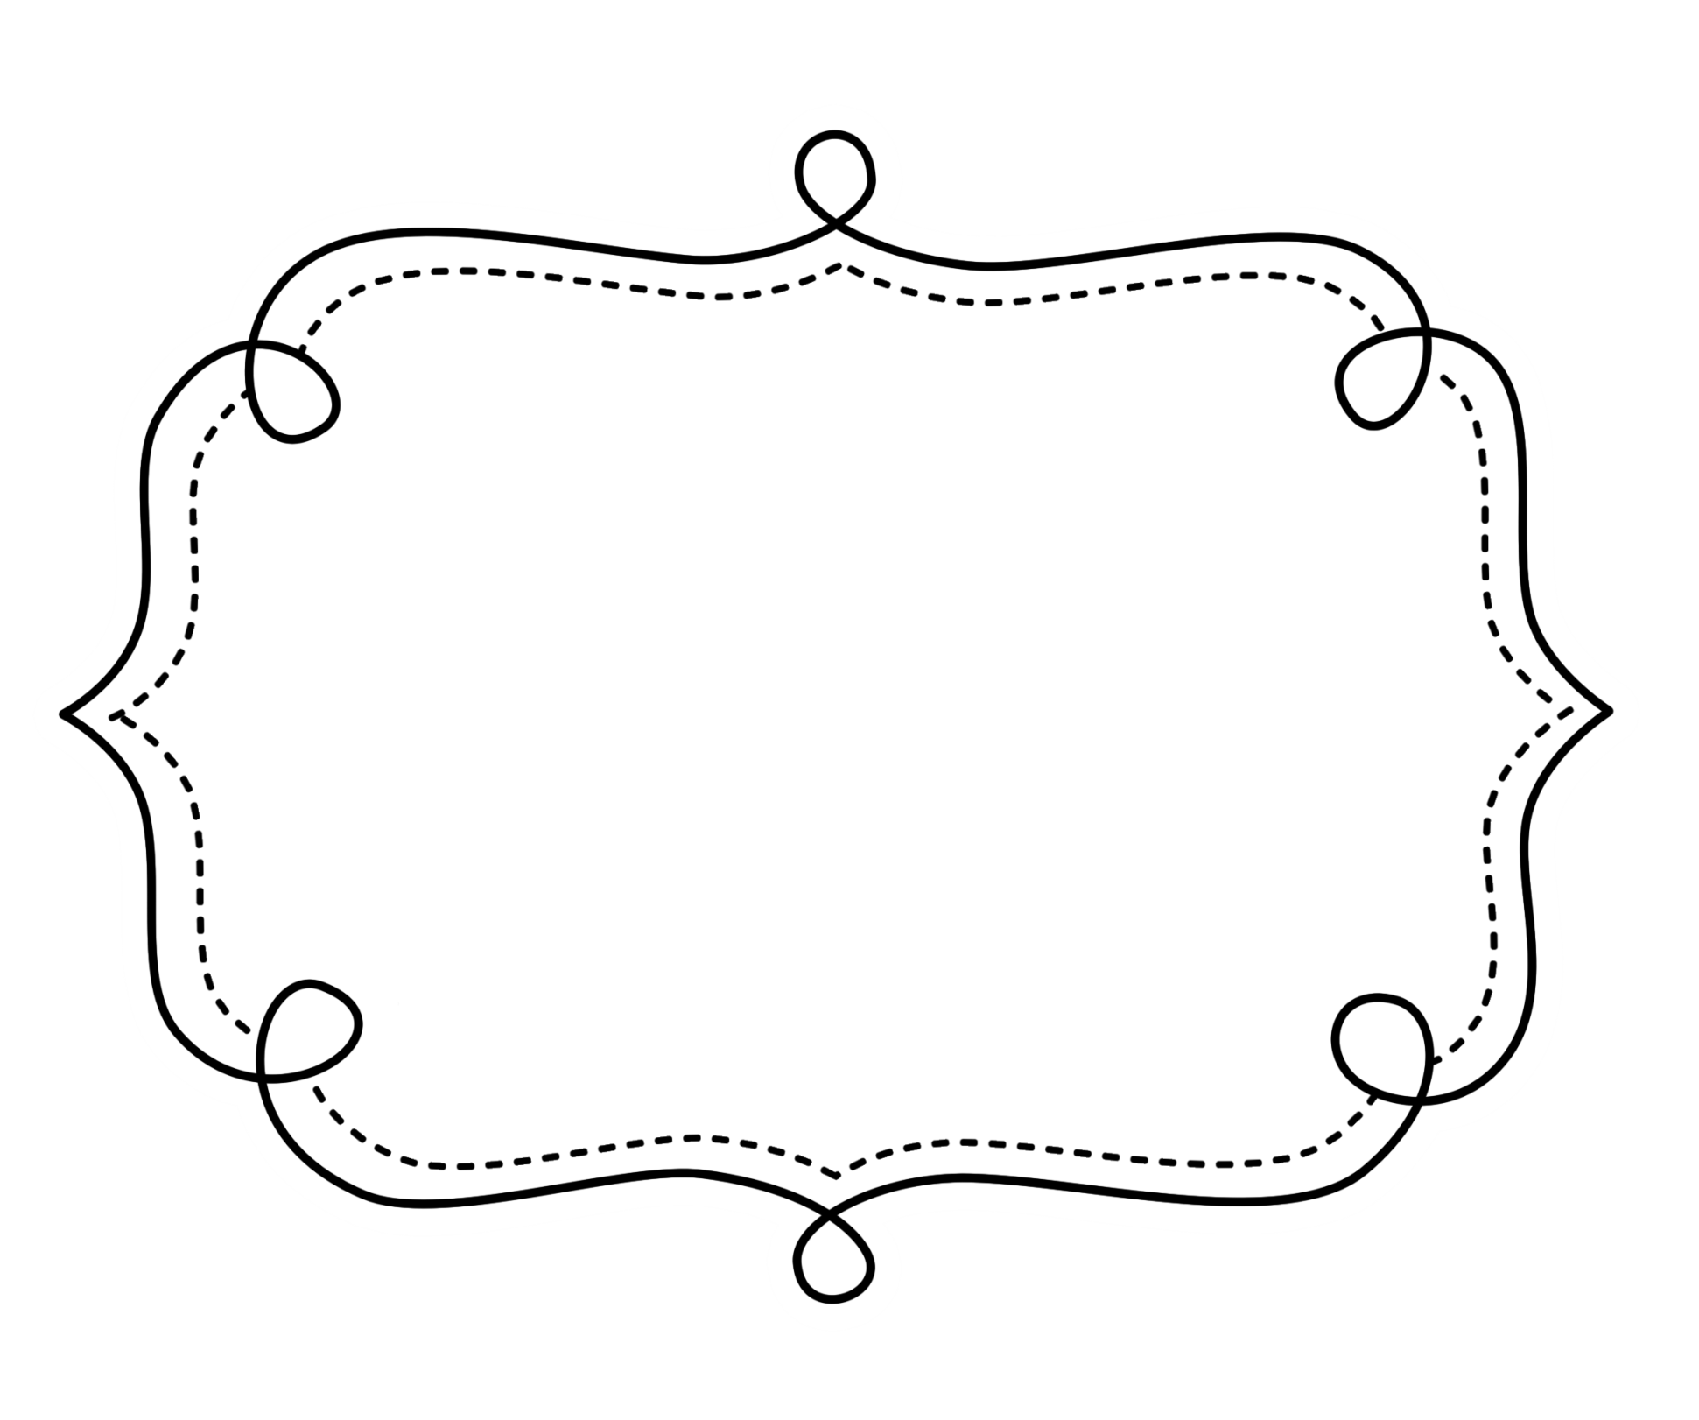
Common Core
Lesson Tracker
English Language Arts
Grade 2
Common Core Lesson Tracker for Grade 2 English Language Arts
Reading: Literature
Key Ideas and Details
CCSS | Introduced | Practiced | Practiced | Assessed | Outcome
CCSS.ELA-Literacy.RL.2.1 Ask and answer such questions as who, what, where, when, why, and how to demonstrate understanding of key details in a text.
CCSS.ELA-Literacy.RL.2.2 Recount stories, including fables and folktales from diverse cultures, and determine their central message, lesson, or moral.
CCSS.ELA-Literacy.RL.2.3 Describe how characters in a story respond to major events and challenges.
Craft and Structure
CCSS | Introduced | Practiced | Practiced | Assessed | Outcome
CCSS.ELA-Literacy.RL.2.4 Describe how words and phrases (e.g., regular beats, alliteration, rhymes, repeated lines) supply rhythm and meaning in a story, poem, or song.
CCSS.ELA-Literacy.RL.2.5 Describe the overall structure of a story, including describing how the beginning introduces the story and the ending concludes the action.
CCSS.ELA-Literacy.RL.2.6 Acknowledge differences in the points of view of characters, including by speaking in a different voice for each character when reading dialogue aloud.
Integration of Knowledge and Ideas Reading Literature
CCSS | Introduced | Practiced | Practiced | Assessed | Outcome
CCSS.ELA-Literacy.RL.2.7 Use information gained from the illustrations and words in a print or digital text to demonstrate understanding of its characters, setting, or plot.
(RL.2.8 not applicable to literature)
CCSS.ELA-Literacy.RL.2.9 Compare and contrast two or more versions of the same story (e.g., Cinderella stories) by different authors or from different cultures.
Range of Reading and Level of Text Complexity
CCSS | Checkpoint | Checkpoint | Checkpoint | Checkpoint | Outcome
CCSS.ELA-Literacy.RL.2.10 By the end of the year, read and comprehend literature, including stories and poetry, in the grades 2–3 text complexity band proficiently, with scaffolding as needed at the high end of the range.

Grade 2 English Language Arts
Reading: Informational Text
Key Ideas and Details
CCSS | Introduced | Practiced | Practiced | Assessed | Outcome
CCSS.ELA-Literacy.RI.2.1 Ask and answer such questions as who, what, where, when, why, and how to demonstrate understanding of key details in a text.
CCSS.ELA-Literacy.RI.2.2 Identify the main topic of a multiparagraph text as well as the focus of specific paragraphs within the text.
CCSS.ELA-Literacy.RI.2.3 Describe the connection between a series of historical events, scientific ideas or concepts, or steps in technical procedures in a text.
Craft and Structure
CCSS | Introduced | Practiced | Practiced | Assessed | Outcome
CCSS.ELA-Literacy.RI.2.4 Determine the meaning of words and phrases in a text relevant to a grade 2 topic or subject area.
CCSS.ELA-Literacy.RI.2.5 Know and use various text features (e.g., captions, bold print, subheadings, glossaries, indexes, electronic menus, icons) to locate key facts or information in a text efficiently.
CCSS.ELA-Literacy.RI.2.6 Identify the main purpose of a text, including what the author wants to answer, explain, or describe.

Integration of Knowledge and Ideas Informational Text
CCSS | Introduced | Practiced | Practiced | Assessed | Outcome
CCSS.ELA-Literacy.RI.2.7 Explain how specific images (e.g., a diagram showing how a machine works) contribute to and clarify a text.
CCSS.ELA-Literacy.RI.2.8 Describe how reasons support specific points the author makes in a text.
CCSS.ELA-Literacy.RI.2.9 Compare and contrast the most important points presented by two texts on the same topic.
Range of Reading and Level of Text Complexity
CCSS | Checkpoint | Checkpoint | Checkpoint | Checkpoint | Outcome
CCSS.ELA-Literacy.RI.2.10 By the end of year, read and comprehend informational texts, including history/social studies, science, and technical texts, in the grades 2–3 text complexity band proficiently, with scaffolding as needed at the high end of the range.

Grade 2 English Language Arts
Foundational Skills
Phonics and Word Recognition
CCSS | Introduced |  | Practiced |  | Practiced |  | Assessed |  | Outcome
CCSS.ELA-Literacy.RF.2.3 Know and apply grade-level phonics and word analysis skills in decoding words.
CCSS.ELA-Literacy.RF.2.3a Distinguish long and short vowels when reading regularly spelled one-syllable words.
CCSS.ELA-Literacy.RF.2.3b Know spelling-sound correspondences for additional common vowel teams.
CCSS.ELA-Literacy.RF.2.3c Decode regularly spelled two-syllable words with long vowels.
CCSS.ELA-Literacy.RF.2.3d Decode words with common prefixes and suffixes.
CCSS.ELA-Literacy.RF.2.3e Identify words with inconsistent but common spelling-sound correspondences.
CCSS.ELA-Literacy.RF.2.3f Recognize and read grade-appropriate irregularly spelled words.
Fluency
CCSS.ELA-Literacy.RF.2.4 Read with sufficient accuracy and fluency to support comprehension.
CCSS.ELA-Literacy.RF.2.4a Read grade-level text with purpose and understanding.
CCSS.ELA-Literacy.RF.2.4b Read grade-level text orally with accuracy, appropriate rate, and expression on successive readings.
CCSS.ELA-Literacy.RF.2.4c Use context to confirm or self-correct word recognition and understanding, rereading as necessary.

Grade 2 English Language Arts
WRITING
Text Types and Purposes
CCSS | Introduced | Practiced | Practiced | Assessed | Outcome
CCSS.ELA-Literacy.W.2.1 Write opinion pieces in which they introduce the topic or book they are writing about, state an opinion, supply reasons that support the opinion, use linking words (e.g., because, and, also) to connect opinion and reasons, and provide a concluding statement or section.
CCSS.ELA-Literacy.W.2.2 Write informative/explanatory texts in which they introduce a topic, use facts and definitions to develop points, and provide a concluding statement or section.
CCSS.ELA-Literacy.W.2.3 Write narratives in which they recount a well-elaborated event or short sequence of events, include details to describe actions, thoughts, and feelings, use temporal words to signal event order, and provide a sense of closure.
Production and Distribution of Writing
CCSS | Introduced | Practiced | Practiced | Introduced | Outcome
W.2.4 begins in grade 3)
CCSS.ELA-Literacy.W.2.5 With guidance and support from adults and peers, focus on a topic and strengthen writing as needed by revising and editing.
CCSS.ELA-Literacy.W.2.6 With guidance and support from adults, use a variety of digital tools to produce and publish writing, including in collaboration with peers.

Research to Build and Present Knowledge WRITING
CCSS | Introduced | Practiced | Practiced | Assessed | Outcome
CCSS.ELA-Literacy.W.2.7 Participate in shared research and writing projects (e.g., read a number of books on a single topic to produce a report; record science observations).
CCSS.ELA-Literacy.W.2.8 Recall information from experiences or gather information from provided sources to answer a question.
(W.2.9 begins in grade 4)
Range of Writing
Begins in 3rd Grade

Grade 2 English Language Arts
Speaking and Listening
Comprehension and Collaboration
CCSS | Introduced | Practiced | Practiced | Assessed | Outcome
CCSS.ELA-Literacy.SL.2.1 Participate in collaborative conversations with diverse partners about grade 2 topics and texts with peers and adults in small and larger groups.
CCSS.ELA-Literacy.SL.2.1a Follow agreed-upon rules for discussions (e.g., gaining the floor in respectful ways, listening to others with care, speaking one at a time about the topics and texts under discussion).
CCSS.ELA-Literacy.SL.2.1b Build on others’ talk in conversations by linking their comments to the remarks of others.
CCSS.ELA-Literacy.SL.2.1c Ask for clarification and further explanation as needed about the topics and texts under discussion.
CCSS.ELA-Literacy.SL.2.2 Recount or describe key ideas or details from a text read aloud or information presented orally or through other media.
CCSS.ELA-Literacy.SL.2.3 Ask and answer questions about what a speaker says in order to clarify comprehension, gather additional information, or deepen understanding of a topic or issue.

Grade 2 English Language Arts
Speaking and Listening
Presentation of Knowledge and Ideas
CCSS | Introduced | Practiced | Practiced | Assessed | Outcome
CCSS.ELA-Literacy.SL.2.4 Tell a story or recount an experience with appropriate facts and relevant, descriptive details, speaking audibly in coherent sentences.
CCSS.ELA-Literacy.SL.2.5 Create audio recordings of stories or poems; add drawings or other visual displays to stories or recounts of experiences when appropriate to clarify ideas, thoughts, and feelings.
CCSS.ELA-Literacy.SL.2.6 Produce complete sentences when appropriate to task and situation in order to provide requested detail or clarification. (See grade 2 Language standards 1 and 3 here for specific expectations.)

Grade 2 English Language Arts
Language
Conventions of Standard English
CCSS | Introduced |  | Practiced |  | Practiced |  | Assessed |  | Outcome
CCSS.ELA-Literacy.L.2.1 Demonstrate command of the conventions of standard English grammar and usage when writing or speaking.
CCSS.ELA-Literacy.L.2.1a Use collective nouns (e.g., group).
CCSS.ELA-Literacy.L.2.1b Form and use frequently occurring irregular plural nouns (e.g., feet, children, teeth, mice, fish).
CCSS.ELA-Literacy.L.2.1c Use reflexive pronouns (e.g., myself, ourselves).
CCSS.ELA-Literacy.L.2.1d Form and use the past tense of frequently occurring irregular verbs (e.g., sat, hid, told).
CCSS.ELA-Literacy.L.2.1e Use adjectives and adverbs, and choose between them depending on what is to be modified.
CCSS.ELA-Literacy.L.2.1f Produce, expand, and rearrange complete simple and compound sentences (e.g., The boy watched the movie; The little boy watched the movie; The action movie was watched by the little boy).

Grade 2 English Language Arts
Language
Conventions of Standard English (CONT.)
CCSS | Introduced | Practiced | Practiced | Assessed | Outcome
CCSS.ELA-Literacy.L.2.2 Demonstrate command of the conventions of standard English capitalization, punctuation, and spelling when writing.
CCSS.ELA-Literacy.L.2.2a Capitalize holidays, product names, and geographic names.
CCSS.ELA-Literacy.L.2.2b Use commas in greetings and closings of letters.
CCSS.ELA-Literacy.L.2.2c Use an apostrophe to form contractions and frequently occurring possessives.
CCSS.ELA-Literacy.L.2.2d Generalize learned spelling patterns when writing words (e.g., cage → badge; boy → boil).
CCSS.ELA-Literacy.L.2.2e Consult reference materials, including beginning dictionaries, as needed to check and correct spellings.
Knowledge of Language
CCSS.ELA-Literacy.L.2.3 Use knowledge of language and its conventions when writing, speaking, reading, or listening.
CCSS.ELA-Literacy.L.2.3a Compare formal and informal uses of English

Grade 2 English Language Arts
Language
Vocabulary Acquisition and Use
CCSS | Introduced | Practiced | Practiced | Assessed | Outcome
CCSS.ELA-Literacy.L.2.4 Determine or clarify the meaning of unknown and multiple-meaning words and phrases based on grade 2 reading and content, choosing flexibly from an array of strategies.
CCSS.ELA-Literacy.L.2.4a Use sentence-level context as a clue to the meaning of a word or phrase.
CCSS.ELA-Literacy.L.2.4b Determine the meaning of the new word formed when a known prefix is added to a known word (e.g., happy/unhappy, tell/retell).
CCSS.ELA-Literacy.L.2.4c Use a known root word as a clue to the meaning of an unknown word with the same root (e.g., addition, additional).
CCSS.ELA-Literacy.L.2.4d Use knowledge of the meaning of individual words to predict the meaning of compound words (e.g., birdhouse, lighthouse, housefly; bookshelf, notebook, bookmark).
CCSS.ELA-Literacy.L.2.5 Demonstrate understanding of word relationships and nuances in word meanings.
CCSS.ELA-Literacy.L.2.5a Identify real-life connections between words and their use (e.g., describe foods that are spicy or juicy).
CCSS.ELA-Literacy.L.2.5b Distinguish shades of meaning among closely related verbs (e.g., toss, throw, hurl) and closely related adjectives (e.g., thin, slender, skinny, scrawny).
CCSS.ELA-Literacy.L.2.6 Use words and phrases acquired through conversations, reading and being read to, and responding to texts, including using adjectives and adverbs to describe (e.g., When other kids are happy that makes me happy).

