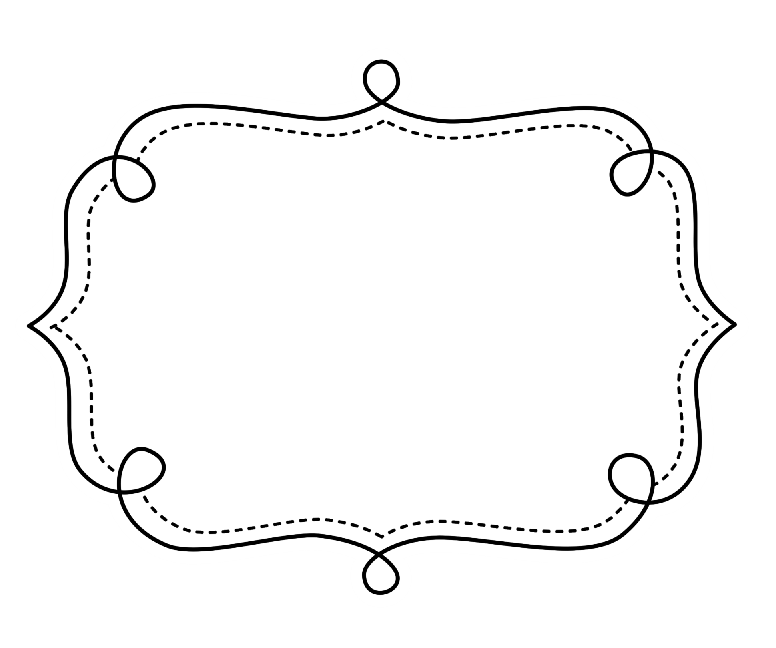
Common Core
Lesson Tracker
English Language Arts
Grade 1
Common Core Lesson Tracker for Grade 1 English Language Arts
Reading: Literature
Key Ideas and Details
CCSS | Introduced | Practiced | Practiced | Assessed | Outcome
CCSS.ELA-Literacy.RL.1.1 Ask and answer questions about key details in a text.
CCSS.ELA-Literacy.RL.1.2 Retell stories, including key details, and demonstrate understanding of their central message or lesson.
CCSS.ELA-Literacy.RL.1.3 Describe characters, settings, and major events in a story, using key details.
Craft and Structure
CCSS | Introduced | Practiced | Practiced | Assessed | Outcome
CCSS.ELA-Literacy.RL.1.4 Identify words and phrases in stories or poems that suggest feelings or appeal to the senses.
CCSS.ELA-Literacy.RL.1.5 Explain major differences between books that tell stories and books that give information, drawing on a wide reading of a range of text types.
CCSS.ELA-Literacy.RL.1.6 Identify who is telling the story at various points in a text.

Integration of Knowledge and Ideas Reading Literature
CCSS | Introduced | Practiced | Practiced | Assessed | Outcome
CCSS.ELA-Literacy.RL.1.7 Use illustrations and details in a story to describe its characters, setting, or events.
(RL.1.8 not applicable to literature)
CCSS.ELA-Literacy.RL.1.9 Compare and contrast the adventures and experiences of characters in stories.
Range of Reading and Level of Text Complexity
CCSS | Checkpoint | Checkpoint | Checkpoint | Checkpoint | Outcome
CCSS.ELA-Literacy.RL.1.10 With prompting and support, read prose and poetry of appropriate complexity for grade 1.

Grade 1 English Language Arts
Reading: Informational Text
Key Ideas and Details
CCSS | Introduced | Practiced | Practiced | Assessed | Outcome
CCSS.ELA-Literacy.RI.1.1 Ask and answer questions about key details in a text.
CCSS.ELA-Literacy.RI.1.2 Identify the main topic and retell key details of a text.
CCSS.ELA-Literacy.RI.1.3 Describe the connection between two individuals, events, ideas, or pieces of information in a text.
Craft and Structure
CCSS | Introduced | Practiced | Practiced | Assessed | Outcome
CCSS.ELA-Literacy.RI.1.4 Ask and answer questions to help determine or clarify the meaning of words and phrases in a text.
CCSS.ELA-Literacy.RI.1.5 Know and use various text features (e.g., headings, tables of contents, glossaries, electronic menus, icons) to locate key facts or information in a text.
CCSS.ELA-Literacy.RI.1.6 Distinguish between information provided by pictures or other illustrations and information provided by the words in a text.

Integration of Knowledge and Ideas Informational Text
CCSS | Introduced | Practiced | Practiced | Assessed | Outcome
CCSS.ELA-Literacy.RI.1.7 Use the illustrations and details in a text to describe its key ideas.
CCSS.ELA-Literacy.RI.1.8 Identify the reasons an author gives to support points in a text.
CCSS.ELA-Literacy.RI.1.9 Identify basic similarities in and differences between two texts on the same topic (e.g., in illustrations, descriptions, or procedures).
Range of Reading and Level of Text Complexity
CCSS | Checkpoint | Checkpoint | Checkpoint | Checkpoint | Outcome
SS.ELA-Literacy.RI.1.10 With prompting and support, read informational texts appropriately complex for grade 1.

Grade 1 English Language Arts
Foundational Skills
Print Concepts
CCSS | Introduced |  | Practiced |  | Practiced |  | Assessed |  | Outcome
CCSS.ELA-Literacy.RF.1.1 Demonstrate understanding of the organization and basic features of print.
CCSS.ELA-Literacy.RF.1.1a Recognize the distinguishing features of a sentence (e.g., first word, capitalization, ending punctuation).
Phonological Awareness
CCSS.ELA-Literacy.RF.1.2 Demonstrate understanding of spoken words, syllables, and sounds (phonemes).
CCSS.ELA-Literacy.RF.1.2a Distinguish long from short vowel sounds in spoken single-syllable words.
CCSS.ELA-Literacy.RF.1.2b Orally produce single-syllable words by blending sounds (phonemes), including consonant blends.
CCSS.ELA-Literacy.RF.1.2c Isolate and pronounce initial, medial vowel, and final sounds (phonemes) in spoken single-syllable words.
CCSS.ELA-Literacy.RF.1.2d Segment spoken single-syllable words into their complete sequence of individual sounds (phonemes).

Grade 1 English Language Arts
Foundational Skills
Phonics and Word Recognition
CCSS | Introduced | Practiced | Practiced | Assessed | Outcome
CCSS.ELA-Literacy.RF.1.3 Know and apply grade-level phonics and word analysis skills in decoding words.
CCSS.ELA-Literacy.RF.1.3a Know the spelling-sound correspondences for common consonant digraphs.
CCSS.ELA-Literacy.RF.1.3b Decode regularly spelled one-syllable words.
CCSS.ELA-Literacy.RF.1.3c Know final -e and common vowel team conventions for representing long vowel sounds.
CCSS.ELA-Literacy.RF.1.3d Use knowledge that every syllable must have a vowel sound to determine the number of syllables in a printed word.
CCSS.ELA-Literacy.RF.1.3e Decode two-syllable words following basic patterns by breaking the words into syllables.
CCSS.ELA-Literacy.RF.1.3f Read words with inflectional endings.
CCSS.ELA-Literacy.RF.1.3g Recognize and read grade-appropriate irregularly spelled words.

Grade 1 English Language Arts
Foundational Skills
Fluency
CCSS | Introduced | Practiced | Practiced | Assessed | Outcome
CCSS.ELA-Literacy.RF.1.4 Read with sufficient accuracy and fluency to support comprehension.
CCSS.ELA-Literacy.RF.1.4a Read grade-level text with purpose and understanding.
CCSS.ELA-Literacy.RF.1.4b Read grade-level text orally with accuracy, appropriate rate, and expression on successive readings.
CCSS.ELA-Literacy.RF.1.4c Use context to confirm or self-correct word recognition and understanding, rereading as necessary.

Grade 1 English Language Arts
WRITING
Text Types and Purposes
CCSS | Introduced | Practiced | Practiced | Assessed | Outcome
CCSS.ELA-Literacy.W.1.1 Write opinion pieces in which they introduce the topic or name the book they are writing about, state an opinion, supply a reason for the opinion, and provide some sense of closure.
CCSS.ELA-Literacy.W.1.2 Write informative/explanatory texts in which they name a topic, supply some facts about the topic, and provide some sense of closure.
CCSS.ELA-Literacy.W.1.3 Write narratives in which they recount two or more appropriately sequenced events, include some details regarding what happened, use temporal words to signal event order, and provide some sense of closure.
Production and Distribution of Writing
CCSS | Introduced | Practiced | Practiced | Introduced | Outcome
(W.1.4 begins in grade 3)
CCSS.ELA-Literacy.W.1.5 With guidance and support from adults, focus on a topic, respond to questions and suggestions from peers, and add details to strengthen writing as needed.
CCSS.ELA-Literacy.W.1.6 With guidance and support from adults, use a variety of digital tools to produce and publish writing, including in collaboration with peers.

Research to Build and Present Knowledge WRITING
CCSS | Introduced | Practiced | Practiced | Assessed | Outcome
CCSS.ELA-Literacy.W.1.7 Participate in shared research and writing projects (e.g., explore a number of “how-to” books on a given topic and use them to write a sequence of instructions).
CCSS.ELA-Literacy.W.1.8 With guidance and support from adults, recall information from experiences or gather information from provided sources to answer a question.
(W.1.9 begins in grade 4)
Range of Writing
Begins in 3rd Grade

Grade 1 English Language Arts
Speaking and Listening
Comprehension and Collaboration
CCSS | Introduced | Practiced | Practiced | Assessed | Outcome
CCSS.ELA-Literacy.SL.1.1 Participate in collaborative conversations with diverse partners about grade 1 topics and texts with peers and adults in small and larger groups.
CCSS.ELA-Literacy.SL.1.1a Follow agreed-upon rules for discussions (e.g., listening to others with care, speaking one at a time about the topics and texts under discussion).
CCSS.ELA-Literacy.SL.1.1b Build on others’ talk in conversations by responding to the comments of others through multiple exchanges.
CCSS.ELA-Literacy.SL.1.1c Ask questions to clear up any confusion about the topics and texts under discussion.
CCSS.ELA-Literacy.SL.1.2 Ask and answer questions about key details in a text read aloud or information presented orally or through other media.
CCSS.ELA-Literacy.SL.1.3 Ask and answer questions about what a speaker says in order to gather additional information or clarify something that is not understood.

Grade 1 English Language Arts
Speaking and Listening
Presentation of Knowledge and Ideas
CCSS | Introduced | Practiced | Practiced | Assessed | Outcome
CCSS.ELA-Literacy.SL.1.4 Describe people, places, things, and events with relevant details, expressing ideas and feelings clearly.
CCSS.ELA-Literacy.SL.1.5 Add drawings or other visual displays to descriptions when appropriate to clarify ideas, thoughts, and feelings.
CCSS.ELA-Literacy.SL.1.6 Produce complete sentences when appropriate to task and situation. (See grade 1 Language standards 1 and 3 here for specific expectations.)

Grade 1 English Language Arts
Language
Conventions of Standard English
CCSS | Introduced |  | Practiced |  | Practiced |  | Assessed |  | Outcome
CCSS.ELA-Literacy.L.1.1 Demonstrate command of the conventions of standard English grammar and usage when writing or speaking.
CCSS.ELA-Literacy.L.1.1a Print all upper- and lowercase letters.
CCSS.ELA-Literacy.L.1.1b Use common, proper, and possessive nouns.
CCSS.ELA-Literacy.L.1.1c Use singular and plural nouns with matching verbs in basic sentences (e.g., He hops; We hop).
CCSS.ELA-Literacy.L.1.1d Use personal, possessive, and indefinite pronouns (e.g., I, me, my; they, them, their, anyone, everything).
CCSS.ELA-Literacy.L.1.1e Use verbs to convey a sense of past, present, and future (e.g., Yesterday I walked home; Today I walk home; Tomorrow I will walk home).
CCSS.ELA-Literacy.L.1.1f Use frequently occurring adjectives.
CCSS.ELA-Literacy.L.1.1g Use frequently occurring conjunctions (e.g., and, but, or, so, because).
CCSS.ELA-Literacy.L.1.1h Use determiners (e.g., articles, demonstratives).
CCSS.ELA-Literacy.L.1.1i Use frequently occurring prepositions (e.g., during, beyond, toward).
CCSS.ELA-Literacy.L.1.1j Produce and expand complete simple and compound declarative, interrogative, imperative, and exclamatory sentences in response to prompts.

Grade 1 English Language Arts
Language
Conventions of Standard English (cont.)
CCSS | Introduced |  | Practiced |  | Practiced |  | Assessed |  | Outcome
CCSS.ELA-Literacy.L.1.2 Demonstrate command of the conventions of standard English capitalization, punctuation, and spelling when writing.
CCSS.ELA-Literacy.L.1.2a Capitalize dates and names of people.
CCSS.ELA-Literacy.L.1.2b Use end punctuation for sentences.
CCSS.ELA-Literacy.L.1.2c Use commas in dates and to separate single words in a series.
CCSS.ELA-Literacy.L.1.2d Use conventional spelling for words with common spelling patterns and for frequently occurring irregular words.
CCSS.ELA-Literacy.L.1.2e Spell untaught words phonetically, drawing on phonemic awareness and spelling conventions.

Grade 1 English Language Arts
Language
Vocabulary Acquisition and Use
CCSS | Introduced | Practiced | Practiced | Assessed | Outcome
CCSS.ELA-Literacy.L.1.4 Determine or clarify the meaning of unknown and multiple-meaning words and phrases based on grade 1 reading and content, choosing flexibly from an array of strategies.
CCSS.ELA-Literacy.L.1.4a Use sentence-level context as a clue to the meaning of a word or phrase.
CCSS.ELA-Literacy.L.1.4b Use frequently occurring affixes as a clue to the meaning of a word.
CCSS.ELA-Literacy.L.1.4c Identify frequently occurring root words (e.g., look) and their inflectional forms (e.g., looks, looked, looking).
CCSS.ELA-Literacy.L.1.5 With guidance and support from adults, demonstrate understanding of word relationships and nuances in word meanings.
CCSS.ELA-Literacy.L.1.5a Sort words into categories (e.g., colors, clothing) to gain a sense of the concepts the categories represent.
CCSS.ELA-Literacy.L.1.5b Define words by category and by one or more key attributes (e.g., a duck is a bird that swims; a tiger is a large cat with stripes).
CCSS.ELA-Literacy.L.1.5c Identify real-life connections between words and their use (e.g., note places at home that are cozy).
CCSS.ELA-Literacy.L.1.5d Distinguish shades of meaning among verbs differing in manner (e.g., look, peek, glance, stare, glare, scowl) and adjectives differing in intensity (e.g., large, gigantic) by defining or choosing them or by acting out the meanings.
CCSS.ELA-Literacy.L.1.6 Use words and phrases acquired through conversations, reading and being read to, and responding to texts, including using frequently occurring conjunctions to signal simple relationships (e.g., because).

