

By Genia Connell

**75 Summer Writing Prompts**



**Weekly Writing Prompts**

Below are enough writing prompts to keep you busy all summer! **Try to write at least two each month.** You should have a minimum of six pieces of completed writing when school begins in September. (That does not mean write six times the last week of August!) Choose from any of the topics below. You do not have to write them only on that specific day or during that week (For example, it’s okay to write about a July topic in August.) Use looseleaf paper or your composition notebook for your writing. Turn your writing into your teacher in the fall, and of course it’s okay to have more than six pieces of writing!

**Remember:**

* Do not rush through these writing assignments. Each piece should be an example of quality work. Always reread your work, then reread it again!
* If a prompt says to write a paragraph, remember to start with an introductory sentence, include 3-5 detail sentences and end with a concluding sentence. That means a minimum of five sentences!
* Students going into fourth grade know that sentences begin with capital letters as do all proper nouns (specific names of people, places and things.) Fourth graders don’t even think of writing sentences that are fragments or do not have ending punctuation. They also know proper spelling is important. Do not “guess” at how to spell words. Look them up or ask!

C:\Users\Genia\AppData\Local\Microsoft\Windows\Temporary Internet Files\Content.IE5\Y3M7S91U\MC900361472[1].wmf**June 14**

Today is Flag Day. Visit this site, <http://www.usflag.org/history/flagday.html> to learn a little about the history of this holiday. Write a paragraph explaining

**June 15**

Did you know today is World Smile Power Day? Make a list of ten kind acts you could do today to make someone smile. Try at least three of the things you wrote down. In your journal write down how people reacted to your efforts. How did it make you feel when you made people smile?

**June 16**

C:\Users\econnell\AppData\Local\Microsoft\Windows\Temporary Internet Files\Content.IE5\OQFOPG0N\MC900292252[1].wmfToday is Father’s Day! Make a card for your dad or another special person in your life that tells him how you feel. Use your best effort to show you care. Draw a nice picture on the front and write your message inside.

**June 17**

June is “National Fresh Fruit and Vegetable Month,” and today is “Eat Your Vegetables Day.” Some kids don’t enjoy eating fruits and vegetables.  Write a persuasive letter to a friend who does not like vegetables convincing them of the importance of consuming the daily, recommended amount of fruits and vegetables. Give them three reasons for eating their vegetables and give them at least two ideas of delicious ways to eat vegetables. Remember to have a greeting and a closing on your letter.

C:\Users\Genia\AppData\Local\Microsoft\Windows\Temporary Internet Files\Content.IE5\GI6C37UJ\MC900389772[1].wmf**June 18**

On this day in 1983, Sally Ride became the first woman in space. What would you like to be the first to do? Go into the future and write a newspaper article that tells the world the *who, what, when* and *where* of your great accomplishment as *“The very first person to ever…”* Include quotes from yourself and other people who know you.

**June 19**

Today is known as *Juneteenth*. This special day commemorates the ending of slavery in the United States in 1865. Write a speech about what freedom means to you. Perform the speech for someone at your home or tape the speech and become your own audience.

C:\Users\Genia\AppData\Local\Microsoft\Windows\Temporary Internet Files\Content.IE5\GI6C37UJ\MC900297809[1].wmf**June 20**

June is National Safety Month. Using the computer, create a brochure for your classmates that details at least four rules that should always be followed for safety’s sake. Officer Buckle would be so proud of you for choosing this one!

**June 21** Today is the first day of summer! What is your favorite summer activity? Write a paragraph telling what you like to do best during the summer. Remember paragraphs have an introductory sentence, 3-4 detail sentences and a concluding sentence.

**June 22**

C:\Users\Genia\AppData\Local\Microsoft\Windows\Temporary Internet Files\Content.IE5\YIID5PCB\MC900036348[1].wmfThe largest hailstone on record was recovered on June 22, 2003, in Aurora, Nebraska. With a diameter of seven inches, this hailstone was nearly as large as a soccer ball. Write a fictional narrative about a day that you were outside playing when something unusual started falling from the sky. What was it? What did you do? Remember to start with an attention-grabbing beginning, a middle with important details and an ending that wraps up your story for the audience.

**June 23** On this day in 1868, the typewriter was patented. We have come a long way since the first typewriter. Use a Venn diagram (two intersecting circles) to compare and contrast the typewriter and a laptop computer. How are they the same; how are they different? If you have never seen a typewriter, you may need to do some research to complete this activity!

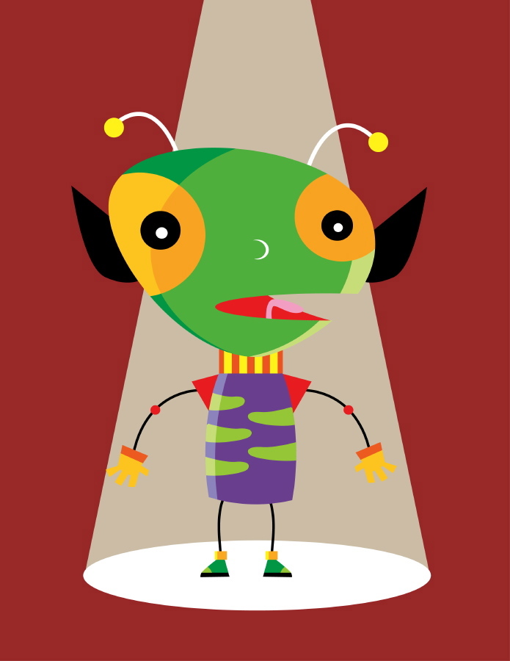**June 24** Today is “U.F.O. Day.” The first documented UFO sighting was on this day. Do you believe in UFOs and/or life on other planets? Write a short story about what happened to you one day when you were on your way to school and you saw a spaceship land on your school’s playground. Tell about the adventures you had after coming face to face with an alien!

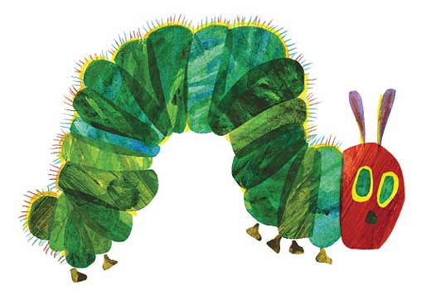**June 25** On June 25, 1929, author Eric Carle was born. The Hungry Caterpillar, which was first published in 1969, has now been published in over 30 different languages. Why do you think this book has been so popular with children from around the world? OR What is your very favorite Eric Carle book and why? Give at least two reasons.

**June 26-30** The last week of June is “National Camping Week.” Plan a camping trip for your family. Be sure to include the following:

* Where would you want to go? Write a paragraph telling where you would like to camp and why.
* What would you need to bring? For this part, make a list of everything you would need for a family camping trip. Don’t forget your toothbrush or items needed for activities like fishing!
* What activities would you like to do at the campsite? Write a second paragraph telling what you would like to do while camping.

Draw a picture of the camping trip you just planned.



**July 1** July 1 is “International Joke Day.” Many people love to tell jokes. Create several jokes of your own to share with your family. You may want to read a few different types of jokes to help you get started. Write down your five favorite jokes. They can be ones you made up, or ones that you have heard or read somewhere.

**July 2** On this day in 1900, the first Zeppelin (blimp) flew. This ship, named after Ferdinand von Zeppelin, was initially used as an experiment for regular airship travel. While in existence, the ship flew more than one million miles with a perfect passenger safety record. Today we often see blimps, or zeppelins, flying over sporting events. Would you like to travel in an airship like this? Explain why or why not? Then design a blimp decorated any way you like.

**July 3** July 3 marks the beginning of the “Dog Days of Summer.” These days are typically the hottest and most humid time of the year. They get their name due to the fact these days occur when the “Dog Star” Sirius raises before the sun. Write a paragraph about your favorite “Dog Day” activity. What do you like to do best on a hot, lazy day?

**July 4** On July 4, 1776, the United States declared its independence from Britain. Every year we celebrate this holiday with fireworks. How do you think this tradition came to be? Do some research to find out why we use fireworks on the 4th of July. Write a paragraph explaining what you discovered.

**July 5** P.T Barnum was born on this day in 1810. He was a great circus ringmaster and helped start the famous Ringling Brothers, Barnum & Bailey Circus. If you could be a performer in a circus, what would you like to do? Would you train tigers, walk on a tightrope, be a funny clown or do one of the hundreds of other jobs? Write a paragraph telling what you would like to do at a circus and why. Draw a picture of you doing your job!

**July 6** On July 6th the first picture postcard was made.  Design a postcard of a place you have visited or would like to visit. On your postcard, write a note to a friend or family member from that place telling how your vacation is going so far. Remember to include a greeting and a closing.

**July 7** Would you believe July 7th is “Macaroni Day?”  Think about your favorite food that includes macaroni. Find a recipe for that dish. What are the ingredients? Make a shopping list that includes everything you would need to buy at the store (assume you have none of the food at home) to make your favorite dish that includes macaroni.

**July 8**On this day in 1835, the Liberty Bell cracked while being rung at the funeral of John Marshall, the longest serving Chief Justice of the Supreme Court (1801-1835.)  Using books or resources on the Internet, write down five (5) facts about the Liberty Bell that you find the most interesting. Make sure you include (at the end) where you found your information.

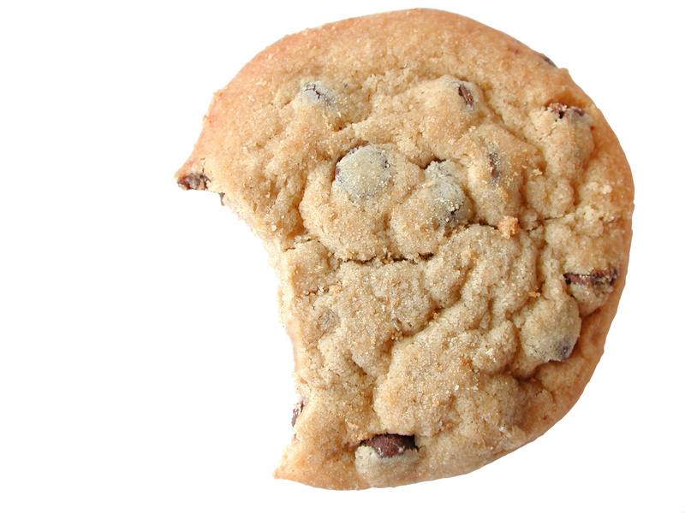**July 9**  
July 9th is “National Sugar Cookie Day.”  Describe the ultimate sugar cookie you would like to make, decorate and eat. Write a paragraph that uses very descriptive words that appeal to your readers’ senses of taste, touch, smell and sight.   Be sure to include the shape, colors and decorations.  Don’t forget to draw a sketch of your amazingly delicious cookie.

**July 10**  
On July 10, 1916, illustrator Martin Provensen was born.  Martin, along with his wife Alice, received the first Caldecott Medal for their illustrations.  Martin also worked for Walt Disney where he collaborated on "Dumbo" and "Fantasia."  Look up several books that received the Caldecott Medal.  Choose one of them and explain why you think it received the award. Tell me the name of the book and the year it received the Caldecott.

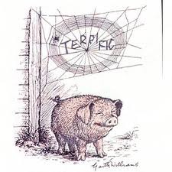**July 11**  
On this day in 1899, author E.B. White was born.  White is the author of Charlotte’s Web.  Like many classic books, this one was made into a movie. Think about a book you have read (or that we have done as a read aloud in class) that has a movie that goes with it that you have seen. (*Tale of Despereaux*, *Shiloh, Indian in the Cupboard, James and the Giant*  *Peach* and *Mouse and the Motorcycle*, are all books we read this year that have movies.) Do you think it’s better to read a book before seeing the movie?  Why or why not?   Write a paragraph that states your opinion and gives at least three reasons to back it up.

**July 12**   
Today is “Paper Bag Day.”  It marks the day that the paper bag manufacturing machine was patented.  Make a list of ten different things you could do with a brown paper grocery bag. Draw your favorite idea.

**July 13** July 13th is “Cheer up the Lonely Day.”  When someone you know is feeing lonely or sad, what do you do to help them feel better?  Design a “Cheer Up” card that would be appropriate to give to someone who is feeling lonely. Include a message on front of the card as well as one inside the card. Don’t forget to sign your card.

**July 14**  
Today is Bastille Day, a national holiday in France. It also happens to be National French Fry Day in the United States. Do you think that is a coincidence? Anyway, think about French Fries. They are the most popular side dish in the United States. The average American eats 29.5 pounds of French fries every year. Do you like French Fries or would you rather have another side dish with your hamburger or hot dog? Your job here is to write about French Fries—write anything you want to write. Tell me how you like to eat them, tell me your favorite restaurant for French Fries (I like McDonald fries with ketchup!) Maybe your grandma makes the best fries in the world and you want to write about that. Go for it!

**July 15**July is “National Picnic Month.”  If you could plan the ideal picnic for your family, what would it be like?  Write a paragraph that includes who would be at your picnic, where it would be at, what you would eat and what activities you would do before/after you eat.

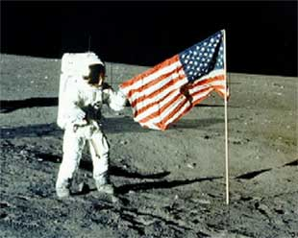**July 16**  
On July 16, 1969, Apollo 11 lifted off for its voyage to the moon.  Do you think we will ever live on the moon?  Why or why not?  Would you like to live there?   What do you imagine life would be like on the moon? Write a paragraph answering all of these questions.

**July 17**  
On this day in 1955, Disneyland opened.  What is your favorite amusement park ride and/or activity? Write a paragraph about it and illustrate your paragraph.

**July 18**  
July is “National Ice Cream Month.”  First, describe your favorite flavor of ice cream.  Next, create a new flavor of ice cream.  What ingredients are in your favorite flavor?  What name will you give your ice cream?

**July 19**  
On July 19, 1916, Eve Merriam was born.  Merriam was a poet, playwright and teacher.  She began writing poetry when she was seven.  Think about your favorite form of poetry and write a poem. Add an illustration to your poem.

**July 20**  
Today is “Moon Day” to mark our first landing on the moon.  There are many character traits an astronaut must possess.  Write a paragraph describing what traits you think an astronaut should have. What do you think is the most important trait of these traits for an astronaut? Why did you select this trait?

**July 21**  
Today is “National Junk Food Day.”  Think about your favorite type of junk food and how often you are allowed to eat this food. Do you think you think kids should be allowed to eat their favorite foods as much as they want? Write a paragraph taking a stand on this question, and give at least three reasons to support your opinion.

**July 22**  
Imagine you could become invisible whenever you wanted to. What are some of the things you would do if you were invisible? Write a story about what one day in your life would be like as an invisible person.

**July 23**Robert Quackenbush, the author and illustrator of nearly two hundred books for young readers, was born on this day.  He once visited Leonard School to speak to the boys and girls in the 1990’s before you were even born! If you could be an author and/or illustrator what types of books would you like to write? In a paragraph, describe the types of books you would like to write and explain why.

**July 24**Today is “Amelia Earhart Day” in honor of her birthday in 1897.  Earhart was the first person to fly solo across the Pacific Ocean.  Using resources in the library or on the interned (with your parent’s permission) learn five facts about Amelia Earhart and summarize them in your own words in a paragraph.

**July 25**  
July is “National Recreation Month.”  After you have looked up the word “recreation” in the dictionary, describe your favorite recreational activity. When and where do you like to do this activity. Why is it your favorite?

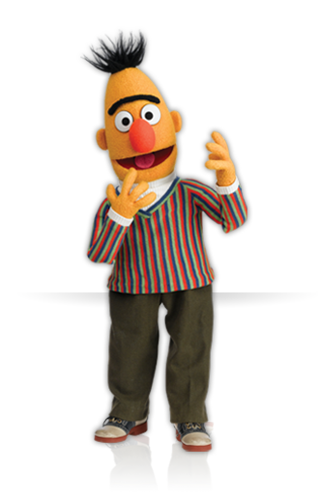**July 26**  
The Sesame Street character Bert was introduced for the first time in 1969. Bert lives with his best friend Ernie and his hobbies include cooking oatmeal, paperclip collecting and watching pigeons. If you could create a new character for Sesame Street, what type of character would it be?  What would you name the character?  What would your character’s hobbies be? Write a paragraph describing your new character and of course, draw a picture of him/her/it!

**July 27**Pretend that television, computers, the Internet, smartphones, ipads, and video games had never been invented. How would you spend your time on a rainy summer afternoon. Write a paragraph describing what you would do without any technology.

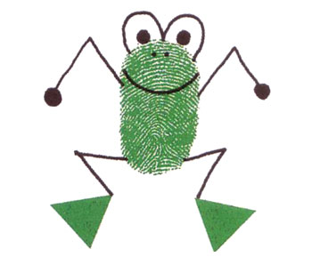**July28**  
On this day the first fingerprint was taken for identification.  Ed Emberley is known for his fingerprint drawings.  Using ink and your fingers (with parent’s permission of course!) create several characters. Give each of them names and think of what their personalities would be like. Write a short story (1-2 pages) about them.

**July** **29**  
Write a poem about your favorite person place or animal. Illustrate it.

**July 30**  
Write a one page personal narrative describing your best day ever!

**July 31**  
On this day in 1790, the first U.S. Patent was issued to Samuel Hopkins.   A patent “provides exclusive rights to make, use, import, sell and offer for sale the invention for up to 20 years.” Why do you think having patents is important?  What might happen if someone didn’t have a patent for their invention?

**August 1**  
On this day in 1779, lawyer and poet Francis Scott Key was born. After witnessing an attack during the War of 1812, Key wrote a poem. This poem was later set to music and became known as, "The Star-Spangled Banner." Write your own poem honoring an event in American history.

**August 2**  
Today is “National Ice Cream Sandwich Day.” Write a paragraph about your favorite dessert and give at least three reasons why you like that particular dessert.

**August 3**  
On August 3, 1492, explorer Christopher Columbus set sail from Spain. Many people remember this with the rhyme, “In 1492, Columbus sailed the ocean blue.” While learning about new things, it sometimes helps to create rhymes to help remember specific facts. Think about something you have trouble remembering. Write about what it is you have trouble remembering, and then write a rhyme that will help you remember it. Can you think of any other rhymes you could make for other things that are tough to remember?

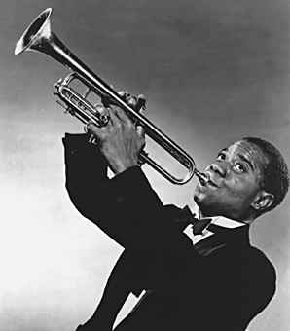**August 4**  
On this date in 1901, musician Louis Armstrong was born. Armstrong was an amazing jazz trumpeter. If you could play any instrument, which instrument would you want to play and why? If you already play an instrument, why did you select that instrument?

**August 5**  
Write a letter to one of your favorite relatives telling them how much you appreciate and love them, and how much fun you have with them. Remember to include a greeting and a closing.

**August 6**  
Today is Friendship Day. What makes a great friend? What characteristics does a friend have? What is a friend willing to do? Create a "want ad" that could go in a newspaper looking for a "Great Friend.”

**August 7**  
Describe your favorite trip to the ocean. If you have not been to the ocean, explain why you would or would not like to go to the ocean.

**August 8**  
On this date in 1899, a man by the name of Albert T. Marshall received the patent for an "automatic refrigerating apparatus," better known as the refrigerator. In at least one paragraph, explain why you think the refrigerator was such an important invention. How would life be different without refrigerators.

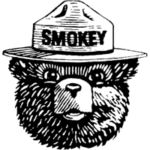**August 9**  
On August 9, 1944, Smokey the Bear was “born.” Smokey is responsible for sharing with people the danger of forest fires. Write a paragraph persuading campers to handle fire carefully. Design a sign you would post in the woods to remind people not to do things that could start a forest fire.

**August 10**  
Herbert Clark Hoover, the 31st President of the United States was born on August 10, 1874. Would you like to be President of the United States? Why or why not? What would be the most challenging thing about being the President of the United States?

**August 11**  
Today is “National Play in the Sand Day.” Describe what your ideal sandcastle would look like. Don't forget to include a sketch.

**August 12** On this day in 1981, IBM announced a new personal computer (PC) for home use. How do you think computers have helped our lives? How do you think computers have possibly harmed our lives?

**August 13**  
August is “National Inventors Month.”  Think of a new invention you would like to create. Write a paragraph describing your invention. Explain why it is needed. Don’t forget to write about how your invention will be used and who will use it. Draw a picture to go along with the description of your invention.

**August 14**

Describe a time that you had to solve a problem with a friend or family member. What was the problem and how was it resolved? This should be a one page narrative.

**August 15**  
Today is “National Relaxation Day.” Write a paragraph that describes one way you have relaxed and had fun during this summer vacation.

C:\Users\Genia\AppData\Local\Microsoft\Windows\Temporary Internet Files\Content.IE5\YIID5PCB\MC900347953[1].wmf**August 16**  
August is National Eye Exam Month. We often take our eye sight for granted. Sit for two minutes with your eyes closed - maybe in your backyard, on your front porch, in your kitchen, outside, any location - and notice what it's like to not "see" anything. How was this similar or different to sitting in this same location with your eyes open? Write a paragraph about how you used your other senses when your eyes were closed. What did you hear, smell, touch?

**August 17**  
If you could travel anywhere in the world, where would you like to travel and why? What would you want to do there?

C:\Users\Genia\AppData\Local\Microsoft\Windows\Temporary Internet Files\Content.IE5\T2EBI3IN\MC900445184[1].wmf**August 18**  
On this date in 1944, author Paula Danziger was born. Danziger is probably best known for her Amber Brown series. If you were going to create your own series of books, what type of characters would you have? What genre of series would you write? Write at least one paragraph explaining your thoughts.

**August 19**  
If you could play a professional sport what one would it be and why? Write a paragraph then design a trading card of you playing this sport.

**August 20**  
Benjamin Harrison, our 23rd President, was born on this date in 1833. Using available to you, write a list of every single United States President in chronological order and the years they were president. (Chronological means in order by date, from first to last.) Begin with George Washington and end with Barack Obama.

**August 21**  
Plan a scrumptious dinner for your family that includes all of your favorite dishes. What will you serve for an appetizer, main course, dessert and drink? Make a one page menu showing what you will be serving that night. Decorate it any way you like.

**August 22**  
Today is “Be an Angel Day.” Describe a time that you were an angel to another person, or a time that someone was an angel to you. This should be a one page narrative.

**August 23**

On this day in 1966, the first photograph of Earth from the moon was taken by the Lunar Orbiter. If you were seeing Earth from the moon for the first time, what would be your thoughts? Pretend you are a scientist at NASA and write a journal entry describing what you see and your thoughts about it. This should be 5-6 sentences.

**August 24**  
On this day in 1932, Amelia Earhart flew across the United States. Write a paragraph about the type of character traits you feel Amelia needed to have to reach this goal of hers? Write a second paragraph telling about a goal that you have and what you will need to do to reach your goal.

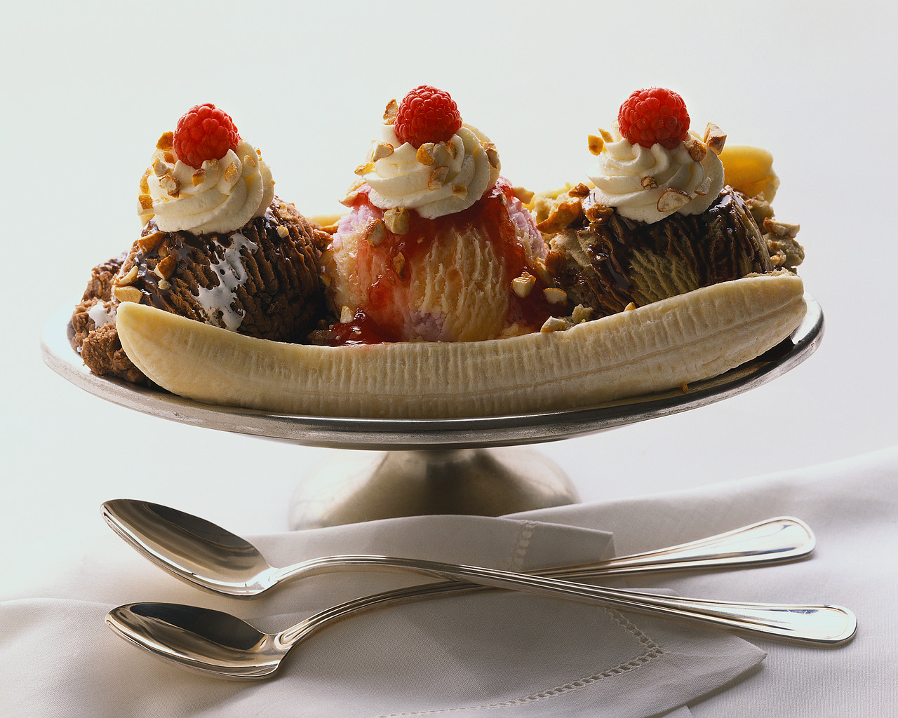**August 25**  
Today is “National Banana Split Day.” Write directions for how to make a delicious banana split. Make sure you include a list of ingredients needed and step by step directions on how to make it.

**August 26**  
On this day in 1916, the National Park Service was established. Use resources available to you (books, Internet) learn about a National Park that is located in our state, or one that you have visited before. Write a paragraph about that part that includes at least five facts about it.

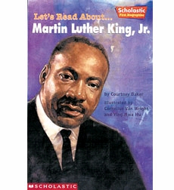**August 27**  
Mother Teresa was born on this day in 1910. Mother Teresa dedicated her life to helping others. Write a list of ten things you can do to help others today or this week. After that, write a paragraph describing what you did and how it helped someone else.

**August 28**  
On this day in 1963, Martin Luther King, Jr. delivered his famous “I Have a Dream” speech. Martin Luther King, Jr.’s dream was for all people, no matter what their skin color, to be treated equal. What is your dream? Write a speech that describes your dream.

**August 29**  
On this day in 1934, the first Scout camp opened. Have you ever been to a camp? If so, describe your experience. If not, describe what camp would you like to attend and what activities you could do there. Would you like to go to a day camp or a sleepover camp? If you want to see some camps in our state, you can look at this website kidscamps.com and search for camps near here.

**August 30**  
On August 30, 2005, Hurricane Katrina hit the Gulf Coast of the United States. This was a Category 4 hurricane. What types of natural disasters affect our region? Ask your family what your family plan is in case of a tornado or fire.

or

Today is also “National Toasted Marshmallow Day.” Write a poem about this tasty treat.

**August 31** On this day in 1870, a famous educator by the name of Maria Montessori was born. Write a letter to next year’s teacher introducing yourself, then describing what you like about school, what you are good at and what you are really looking forward to learning this school year.