Name: _______________________
Directions:
Highlight all short vowel words RED.
Highlight all long vowel words BLUE.
Draw a box around all rhyming words.
Lyrics to:
Take Me Out to the Ball Game
Written by: Jack Norworth
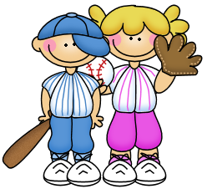
Katie Casey was baseball mad.
She had the fever and she had it bad.
Just to root for the hometown crew,
Every cent, that Katie spent.
On one Saturday her young beau
called to see if she’d like to go
to see a show, but Ms. Kate said,
“No, I’ll tell you what you can do.”
“Take me out to the ball game,
Take me out with the crowd.
Buy me some peanuts and Cracker Jacks,
I don’t care if I never get back.
‘Cause it’s root, root, root for the home team,
if they don’t win, it’s a shame.
‘ Cause it’s one, two, three strikes, you’re out,
at the old ball game.”

Katie Casey saw all the games,
knew the players by their first names.
Told the umpire he was wrong,
all along, and she was strong.
When the score was 2-2,
Katie Casey, she had the clue,
to cheer on the boys,
she knew just what to do.
She made everyone sing this song:

“Take me out to the ball game,
Take me out with the crowd.
Buy me some peanuts and Cracker Jacks,
I don’t care if I never get back.
‘Cause it’s root, root, root for the home team,
if they don’t win, it’s a shame.
‘ Cause it’s one, two, three strikes, you’re out,
at the old ball game.”
clip art by thistle girl: https://www.thistlegirldesigns.com/shop/

