Standard: Create and state a series of rhyming words
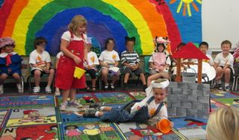
1. *Role-Play Rhymes: (whole group) Role-play is one of my favorite strategies to use when teaching my students how to understand and manipulate rhyming words. Use rhyming poems, chants, or songs to ignite the stage in your classroom. Nursery rhymes are easy to use with role-play and they are filled with rhyming words. Write a nursery rhyme on sentence strips and place them in a pocket chart. Have the students role-play the nursery rhyme then think of new words that rhyme. For example in the nursery rhyme, “Jack and Jill,” have the students think of words that rhyme with hill. Let’s say they come up with bill. Their new lines to role-play would be Jack and Jill went up the hill to pay a bill. Have the students get in cooperative groups and give new words to the traditional nursery rhymes.
Materials needed: sentence strips, a marker, and a pocket chart (In this picture we took it a step further and presented our role-playing in a performance entitled: The Nursery Rhyme Review.
2. *Rhyme Light Rhyme Light: (whole group) This game is played similar to the way you would play Red Light, Green Light. Bring the students outside. The teacher is the caller first so the students get the initial idea (eventually let each of them be the caller). The teacher stands on one end of the playground area and the students stand on the other end. The students are to take one step forward if the two words you say rhyme. They are to stay where they are if the two words don’t rhyme. If the words don’t rhyme and they take a step forward then they need to go back to the beginning.
Materials needed: none
3. *Jump Rope Rhymes: (small group or whole group depending on how many jump ropes you have) Have the student jump the rope every time a word that rhymes is heard. The students can create their own rhymes and jump to them.
Materials needed: jump ropes
4. *Learning rhymes? Have those students visit Reggie the Rhino (for basic or below learners) at Scholastic’s Student Activities link: Computer Lab Favorites.
5. *Want a challenge for your students? Have them make their own I SPY rhyme from one of Scholastic’s online Student Activities on Computer Lab Favorites.

