Shark Hat Craft
by: Andrea Maurer
Makes one hat for each student

Materials needed (for one hat):
- 12” x 18” piece of black or grey construction paper (body)
- 2” x 1” piece of white construction paper (eye)
- 1” x 1” piece of black construction paper (pupil)
- precut fin on black or grey construction paper (fin)
- 2” by 5” piece of white construction paper (teeth)
- pencil
- white sentence strip
- stapler

Directions:
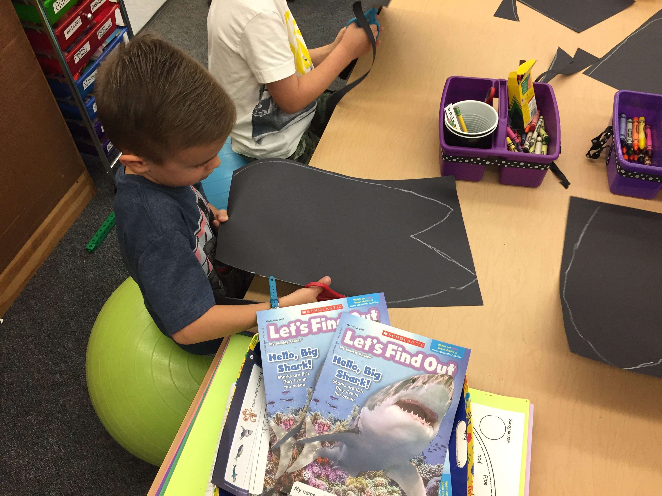
Before giving to students, draw a shark’s body on each 12” x 18” piece of black or grey construction paper. Have each student cut the shark’s body out.

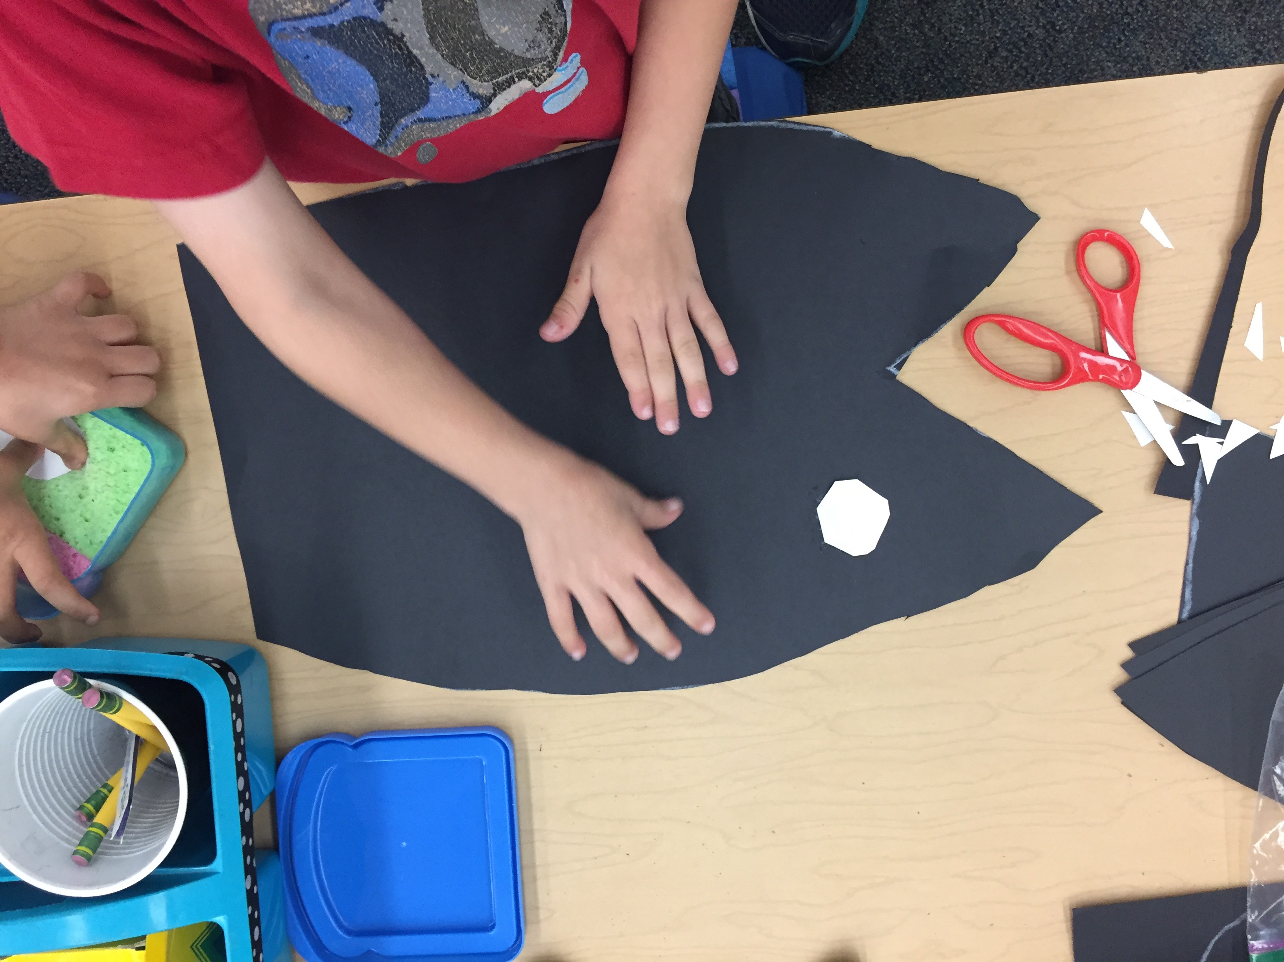
Cut the corners and tips of the 2”x1” piece of white construction paper to make an eye shape. Glue to the shark’s head.

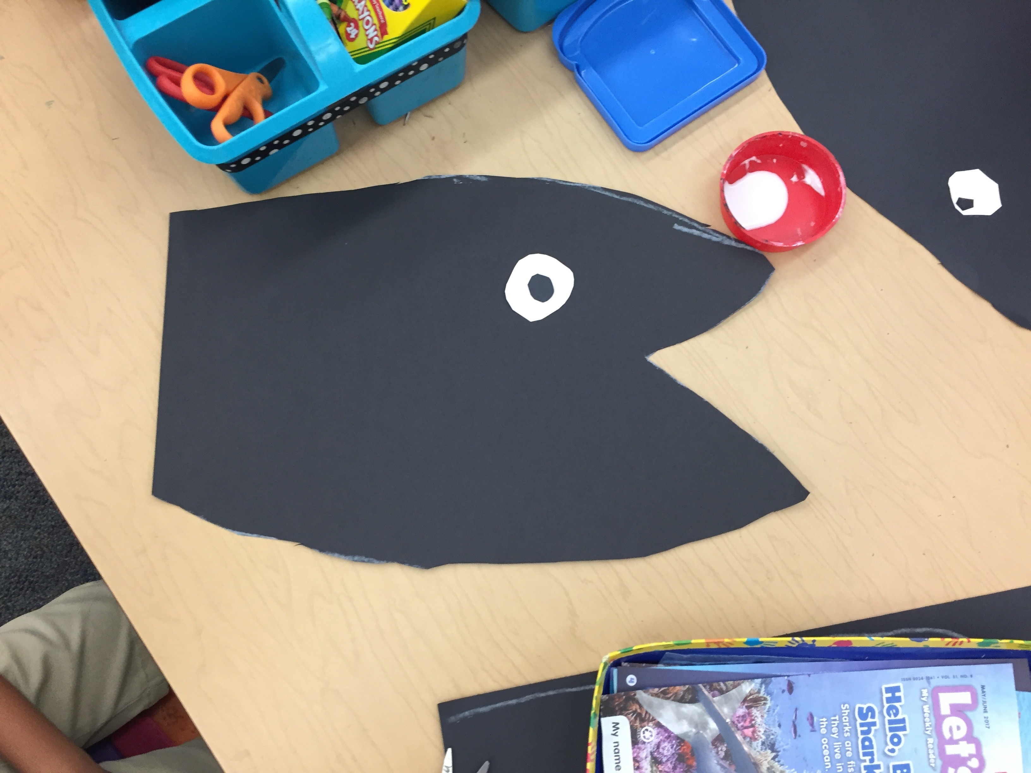
Cut the corners and tips of the 1”x1” piece of black construction paper to make a pupil. Glue to the middle of the eye.

Turn the shark on its back and glue the precut black or grey fin to the top of the body. Cut small triangles from the 2”x 5” piece of white construction paper to make teeth. Glue the teeth inside
the shark’s mouth.

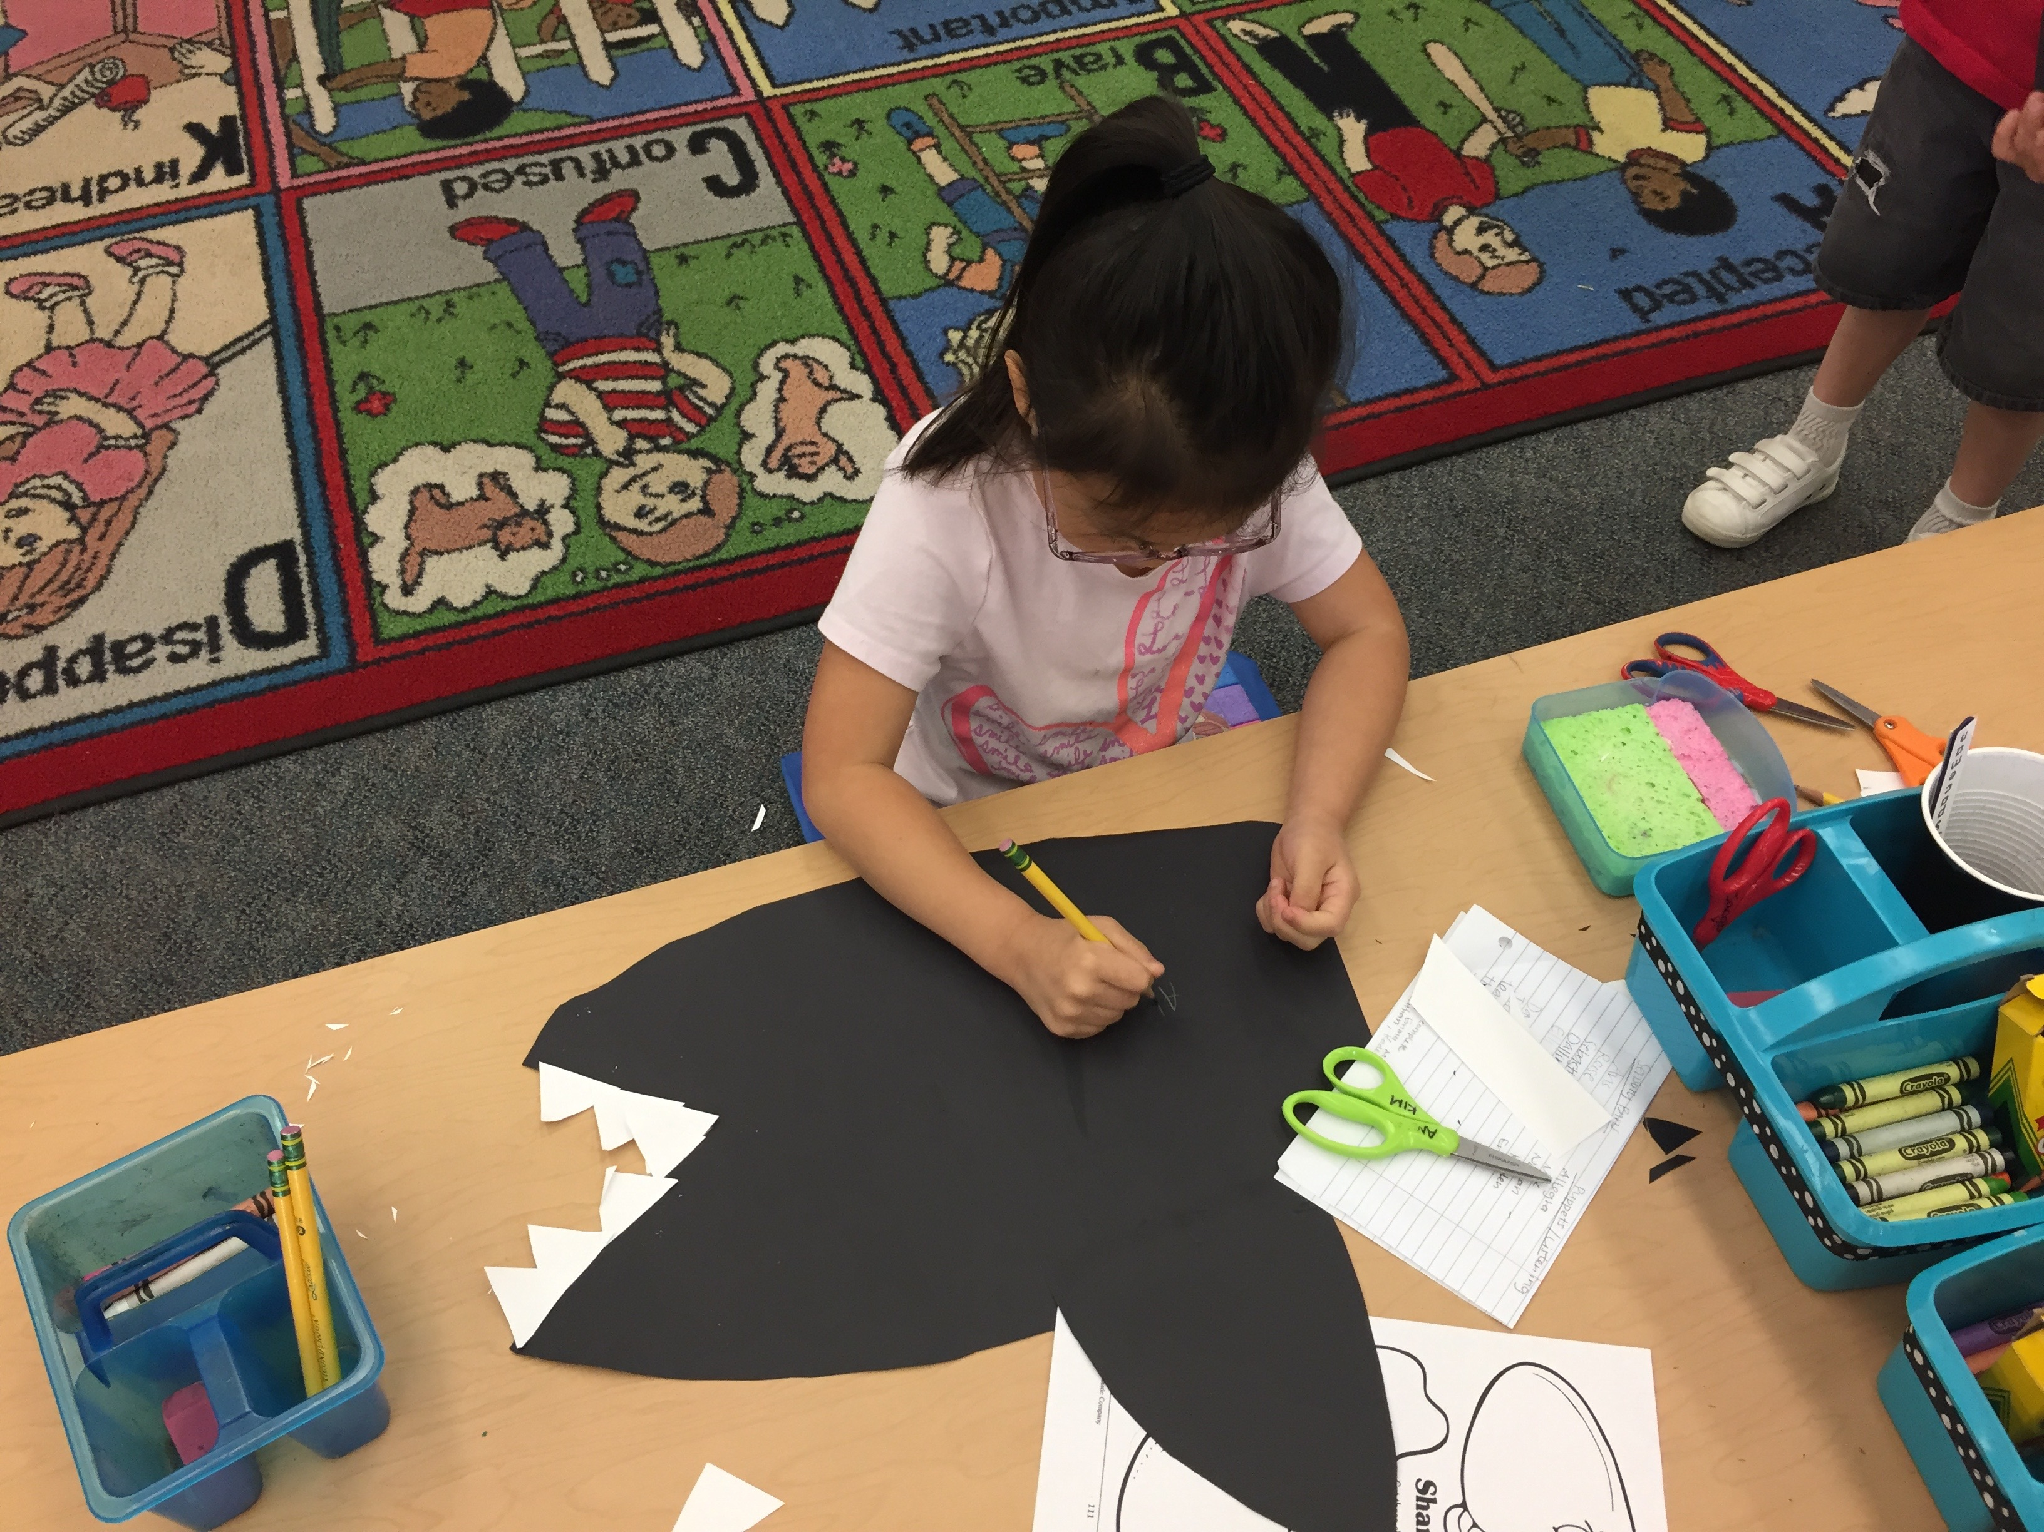
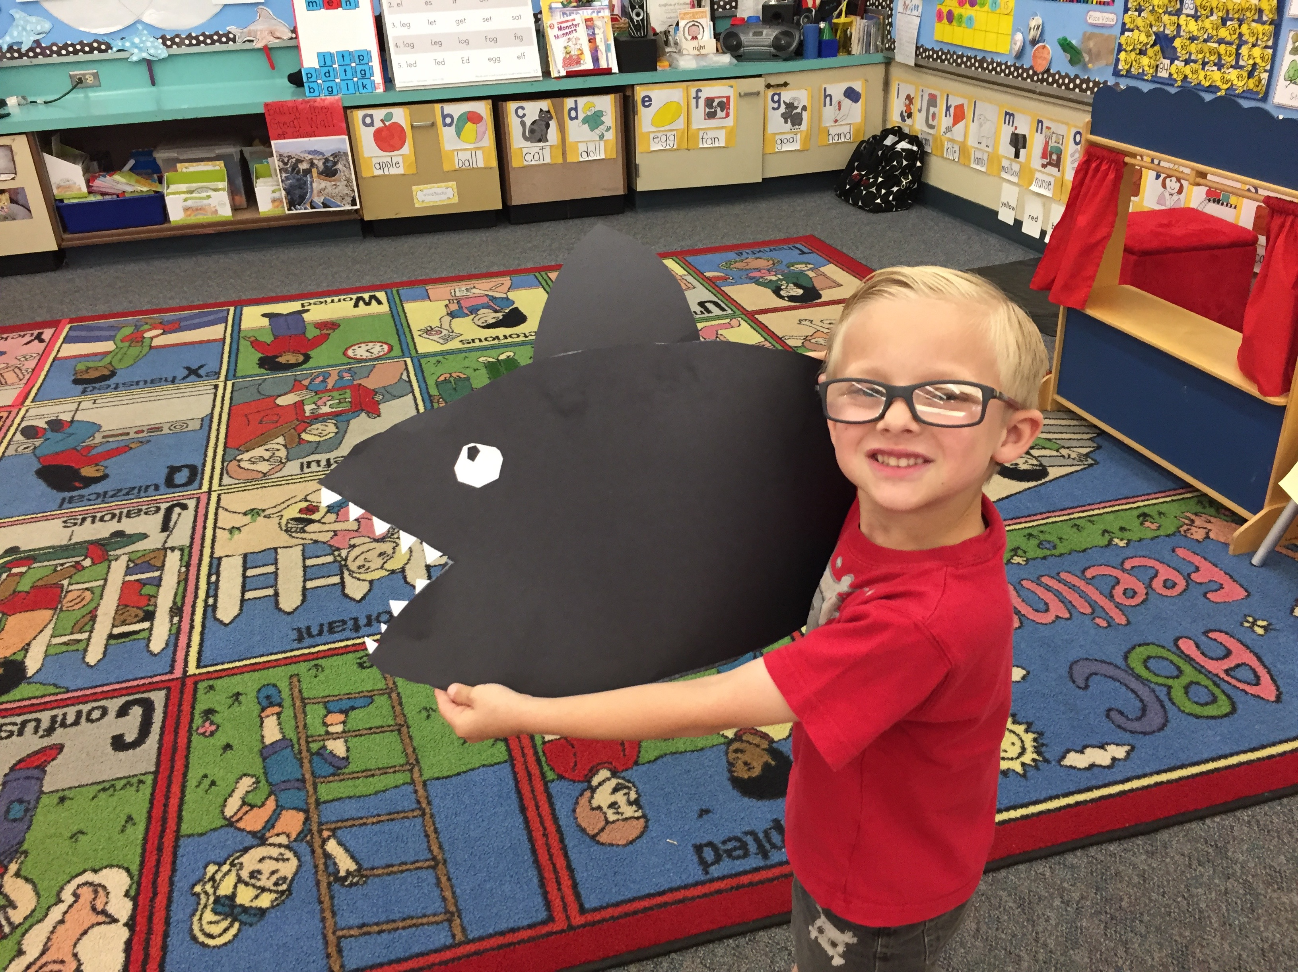

Add a sentence strip to the back of the shark, and measure to the each student’s head. Staple the ends together. Now you have an easy-to-make shark hat!

