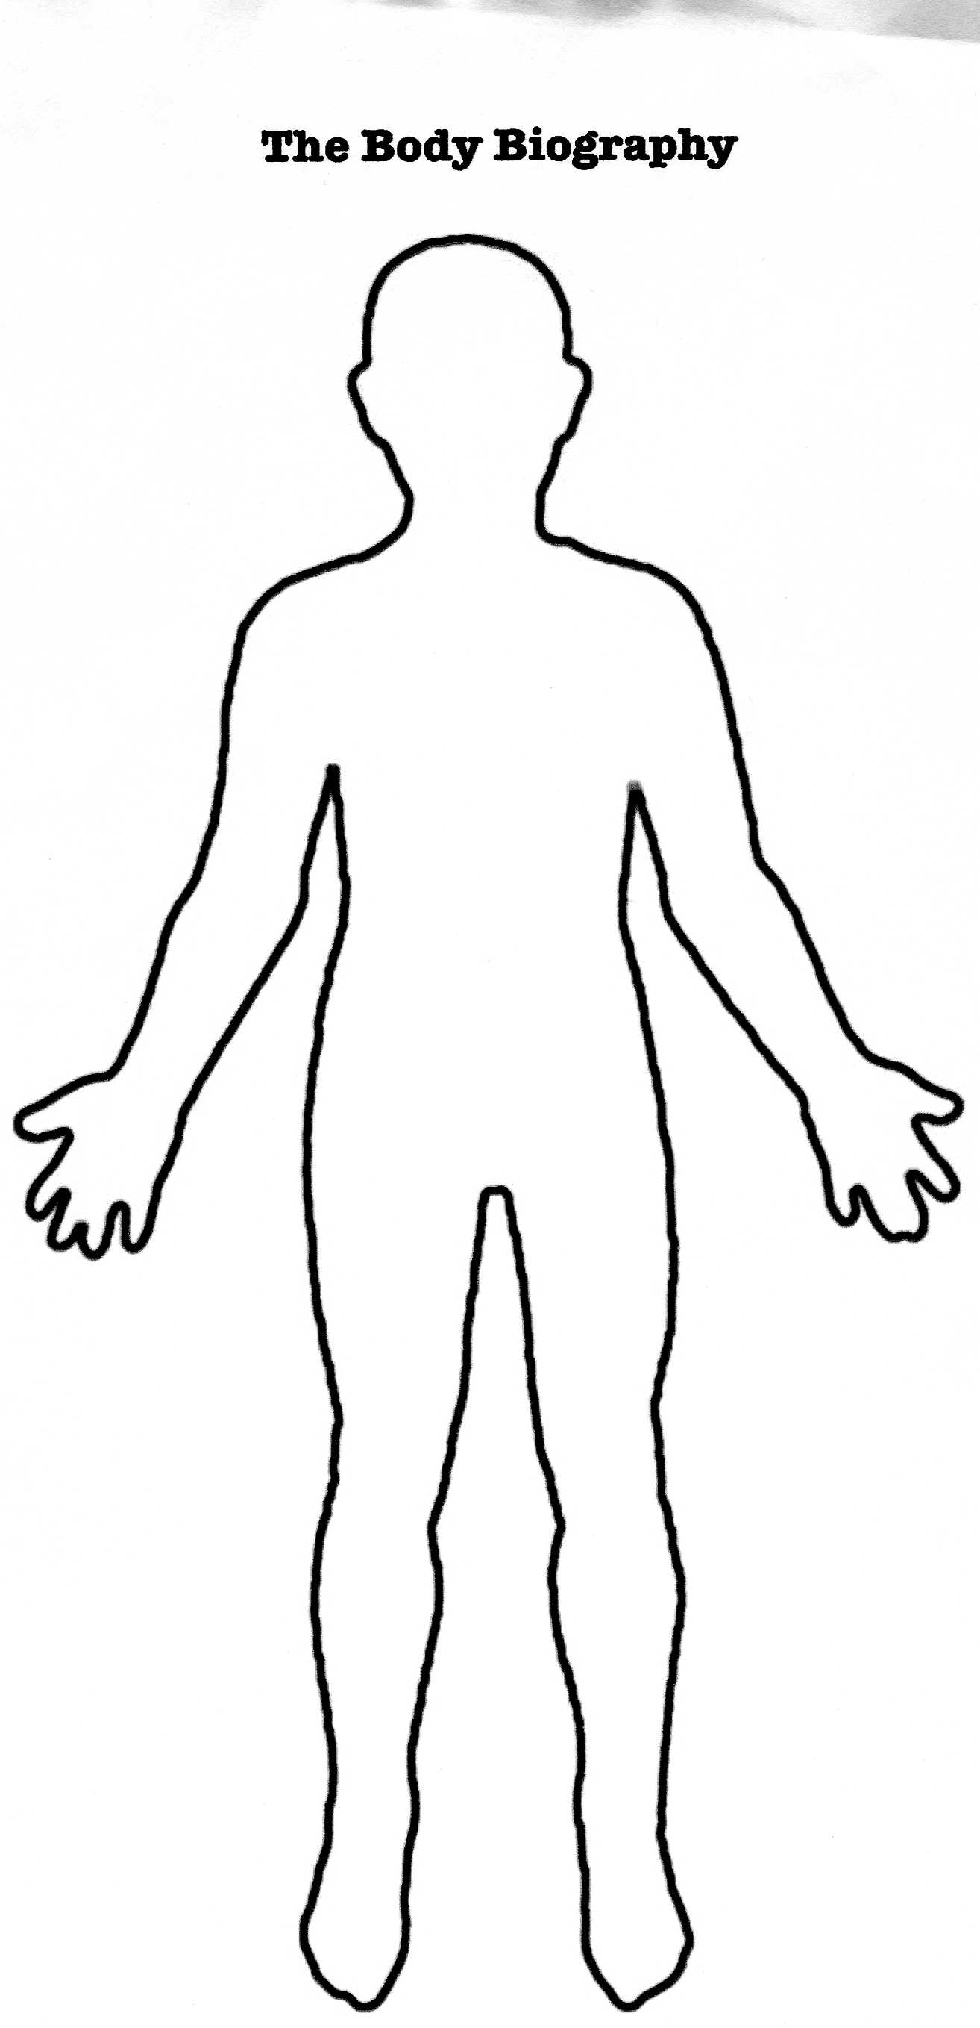
Body Biography Project

Book Title: ________________ Character: _________________

Group Members: ______________, __________________, ____________________

Grading Rubric:

Quotes: At least three quotes and page #s given about the character
Traits/Characteristics: At least two represented and illustrated
Symbolic Items: At least three with descriptive references from the story
Visual Appeal: Creativity, design, etc.
Extras: Any additional elements that bring your character to life
Presentation: Obvious knowledge about character and accurate analysis
Total:

