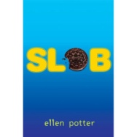
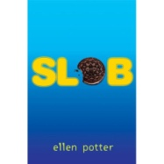
“Slob”: Sketch to Stretch Vocab

Word | Definition | Pg# and Sentence in the book | Sketch of definition
sinister | evil
gizmos | technology or gadgets
relishing | enjoying
confrontational | discuss face to face
empathetic | sensitive to
snickering | make fun of; laugh at
rummaging | searching through
resembled | similar to; looks like
propelled | move forward
nemisis | enemy

